1. Objectives of the Project

- Development of an innovative and cost effective Grey Jute Paving Fabric (GJPF) with a suitable combination of woven and nonwoven jute fabric.

- Preparation of final Bitumen impregnated Jute Paving Fabric (BJPF) with developed Grey Jute Paving Fabric (GJPF) as a cheaper substitute of mastic asphalt which is nowadays used in roads.

- Assessment of the functional performance of the developed BJPF in a recognized laboratory [Central Road Research Institute (CRRI), New Delhi] before field trials under suitable conditions that can withstand the moving loads expected on different categories of roads (e.g. State Highways, Major District Roads and Rural Roads etc.) and standardization of the same.

- Undertaking field trials on operational roads with different traffic intensity for assessment of the end – use performance of the BJPF as per existing National and International Standards in association with Central Road Research Institute, New Delhi.

- Dissemination and transfer of technology (Industry Personnel, Researchers, Students and End - users) on development and application of BJPF in roads.

2. One Page Summary Report on Literature Survey

The Project aims at development of a sandwiched fabric which is a suitable combination of woven and nonwoven fabric followed by bitumen treatment of the developed Grey Jute Paving Fabric (GJPF) with suitable type and grade of bitumen to produce the Bituminized Jute Paving Fabric (BJPF). This developed BJPF is used in the road with mastic asphalt as a partial substitute of mastic asphalt which is now-a-days used for road constructions in general. The use of BJPF in road as overlay fabric is a new concept and has not been tried so far. So, there is no such literature available on BJPF. But some literature on paving fabric and bitumen are available which are discussed in detailed literature review (enclosed as Annexure-I).
Paving fabrics are nonwoven and combination of both woven and nonwoven fabrics that have high elongation and tensile strengths. They are commonly used for stress relief. Literature on woven and nonwoven fabrics are plentiful in previous studies carried out by different researchers.
The Indian Standard Institution defined as a Bitumen as a “Black or dark brown non-crystalline soil or viscous material having adhesive properties derived from petroleum crude either by natural or refinery process.” Bitumen is obtained as the last residue in fractional distillation of crude petroleum. Crude petroleum is a mixture of hydrocarbon of different molecular weights. Bituminous uses can be broadly classified under two main heads.
(a) Civil engineering work (b) Industries
i. Construction of roads, runways, platforms i. electric cables
ii. Mastic floorings for factories, go downs ii. Sealing compound in battery
iii. Water proofing to prevent water seepage iii. Bituminous felts

3. Detailed Report on Literature Survey with Reference

A Detailed Literature Review based on different publications of national and international journals on related subject has been accomplished and the hard copy along with soft copy of the same has already been provided to NJB during the submission of annual progress report in different stipulated times and is again provided with this report as Annexure I.

4. Need Assessment / Market Survey Report
The developed product, Bituminized Jute Paving Fabric (BJPF) is an innovative product and has been never used before, hence the Need Assessment / Market Survey Report were made on Secondary Data and other related information on the subject collected from various published materials and journals available (like Geosynthetic and Geomembrane, IRC journal etc.) with different jute organization, different academic institute (JU, BESUS, West Bengal) research institute (CRRI, New Delhi), news magazine and agencies etc..
Jute has been consumed mainly as packaging material (Hessian and Sacking), alongwith some Jute Diversified Products and Geotextiles. But, Jute Geotextile (JGT) shares only one percent of the total global Geotextile consumption.
Presently, there is no market for the developed product but if the efficacy of the developed product can be proved then there will be huge consumption of Jute. 38% of produced Jute may be consumed for manufacturing of such jute paving fabric, which will be a huge alternative of diversified outlet for jute as a whole. There is also scope of application of such developed product in the National Highways and State Expressways, which will also generate more consumption of Jute (vide Annexure-I of “Market Potential and Need Assessment Survey and Deliverables”).
A detailed Need Assessment Survey Report has already been submitted and is again provided with this report as Annexure – II.

5. Methodology of R & D Part of the Project

The main objective of the Project is to develop Bituminized Jute Paving Fabric (BJPF) which consists of (a) Production of Grey Jute Paving Fabric (GJPF) (b) Production of Bituminized Jute Paving Fabric (BJPF).
(a) Production of Grey Jute Paving Fabric (combination of three layers woven fabric and two layers of nonwoven fabrics)
Production of woven fabric in a conventional Jute Loom with the selected batch.

Production of nonwoven cross lapped batt in Camel Back Cross Lapper with the selected batch.

Combination of produced single layer woven and nonwoven cross lapped batt in a needle punching loom to form a combined layer of woven and nonwoven fabrics.

Combining two layer combined fabric and single layer of woven fabric in a Needle Punching Machine to form final Grey Jute Paving Fabric.

(b) Production of Bituminized Jute Paving Fabric (BJPF)
Grey Jute Paving Fabric has been impregnated with PMB-40 bitumen and other chemicals at required process control parameters.

This developed product has been used in the Pilot and Commercial Field Trials.

6. Detailed Report on R&D
A detailed Report on R&D is provided with this terminal report as Annexure – III.

7. Results and outcomes of R & D activities
The project aims at development of Bituminized Jute Paving Fabric (BJPF) which may be potentially used as a partial substitute of Premixed Carpet (PMC) or Bitumen Mastic. During the development of the product extensive R&D activities have been carried out at Dept. of Jute and Fibre Technology, University of Calcutta and Central Road Research Institute (CRRI), New Delhi (collaborative project partner).The results of R&D activities may be found in the detailed R&D report.
Outcome of R&D Activities
- Grey Jute Paving Fabric (GJPF) has been standardized which is prepared by the combination of 3 layers of Hessian (H) and 2 layers of Nonwoven (NW) in the Needle Punching Loom.

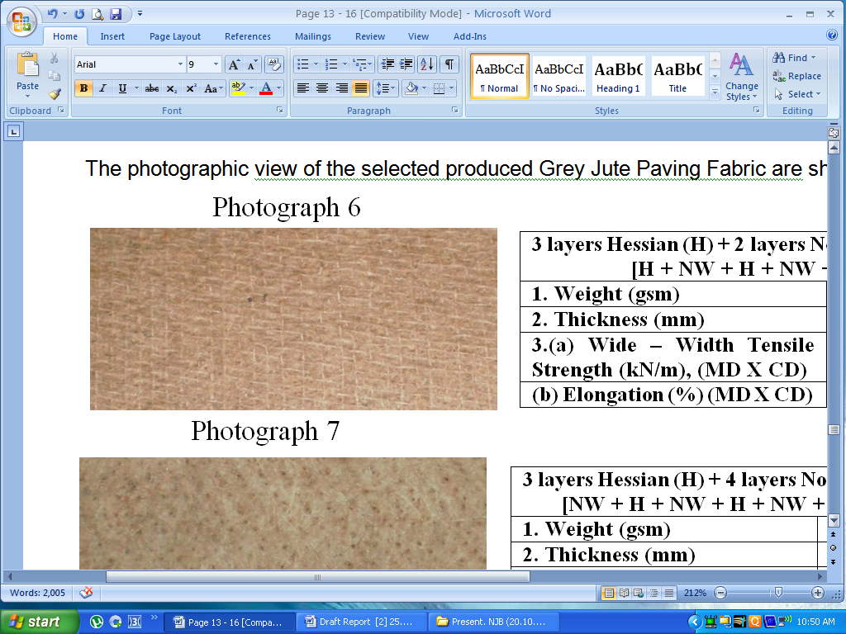
3 layers Hessian (H) + 2 layers Nonwoven (NW)
1. | GSM | 1035
2. | Thickness (mm) | 6.80
3. | Strength (KN/m) [MD X CD] | 25.00 X 26.00
4. | Elongation% [MD X CD] | 6 X 15
5. | Bursting Strength (kg/cm²) | 36.00
Sectional view of GJPF

- PMB 40 has been identified as the suitable type of Bitumen for the application on the Grey Jute Paving Fabric to produce the Bituminized Jute Paving Fabric (BJPF).
- BJPF has been produced in a Bitumen Treatment Plant by a suitable system which has been developed with fine tuning and necessary attachments in the existing production system of the plant.

Specifications of Optimized and Standardized BJPF
- The sectional view of the optimized and standardized Bituminized Jute Paving Fabric produced using 1033 GSM Grey Jute Paving Fabric and PMB 40 Bitumen along with some suitable chemicals
1. | GSM | 3500
2. | Thickness (mm) | 8.0
3. | Strength (KN/m) [MD X CD] | 38.50 X 40.00
4. | Elongation% [MD X CD] | 11.0 X 9.0
5. | Bursting Strength (kg/cm²) | 43.0

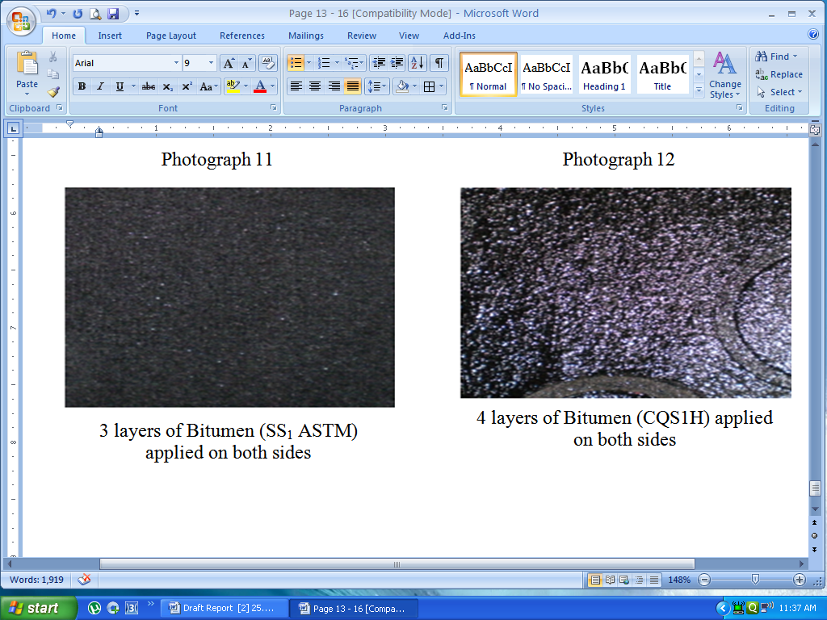
Sectional view of BJPF

Dissemination Seminar/ Workshop
The objective of the workshop was to disseminate the mid-term results / findings of the project among the jute mills, JDP manufacturers/exporters and entrepreneurs, to interact with the Industry representatives and to raise their valuable opinions / views for delivering useful projects outputs to both organized and decentralized jute sectors.
The workshop was attended by about 75 delegates including representatives of NJB, NCJD, IJMA, AJHEEI, and individual jute mills, individual jute diversified product manufacturers / exporters and scientists / technologists of SITRA and IIT, Kharagpur.
The workshop was organized as per following schedule-
- Inaugural Session
- Presentation of the Project Report followed by interaction with the delegates.
- Display of Jute Products produced during the project period.
A detailed Seminar Proceeding has been submitted earlier.

Final Dissemination Seminar/ Workshop
The objective of the workshop was to disseminate the final outcomes / findings of the four JTM-R & D projects among the large scale and small scale jute sector as user industry including jute mills, JDP manufacturers /exporters and entrepreneurs as well as scientists and researchers of jute sector by direct interaction with them in this 2nd Dissemination workshop to receive their feedback and valuable opinions / views for effective utilisation and way forward about the outcome of these JTM-R&D projects in both organized and decentralized jute sectors and relevant users.
The workshop was attended by about 90 delegates including representatives of IJMA, NJB, AJHEEI/JDPEPC, individual jute mills, individual jute diversified product manufacturers / exporters and scientists/ technologists of Jute Research Institutes.

8. Product /Process Standardization
The Grey Jute Paving Fabric (GJPF) has been produced in a conventional Jute Mill having the facility of producing Hessian and Nonwoven Fabrics. Production of Hessian fabric has been done as per the Mill’s Regular Production system and Standards.
FLOW CHART (1) FOR JUTE YARN AND FABRIC MANUFACTURING
BALE OPENING AND SELECTION OF JUTE
SOFTENING
(using Softener or Spreader Machine applying oil or water emulsion)

CONDITIONING OR PILING
CARDING
(using Breaker Card and Finisher Card or using Teaser Card, Breaker Card, Inter and Finisher Card)

DRAWING
(using Push bar Or Screw Gill 1st, 2ndand / or 3rd Drawing Frame)

SPINNING (YARN MANUFACTURE)
(using Slip Draft / Apron Draft Sliver Spinning Frame)

WARP YARNS
WEFT YARNS
SPOOL WINDING
(using Drum Winding Type or other type Spool Winding Machine)
COP WINDING
(using Vertical / Horizontal Cop Winding Machine)

SIZING & BEAMING (WARPING)

WOVEN FABRIC (Hessian)
(in conventional Jute Loom)

Combined fabric of single layer woven and single layer nonwoven has been produced in the needle punching loom with required machine parameters and process parameters as shown in the flowchart.
BALE OPENING AND SELECTION OF JUTE

SOFTENING
(using Softener or Spreader Machine applying oil or water emulsion)

CONDITIONING OR PILING
CARDING
(using Breaker Card and Finisher Card or using Teaser Card, Breaker Card, Inter and Finisher Card)

Line Card before Needle Loom
Laying of carded web in Camel Back Cross Lapper

Laying of carded web in cross conveyor from Camel Back Cross Lapper
Addition of Single layer Hessian Fabric in the Cross Lapper

Combined Fabric [Combination of single layer Hessian Fabric and Carded Web in the Needle punching Loom with required parameters*]

Combined Fabric
Hessian Fabric
(as shown in Flow Chart- 1)
Combined Fabric

Grey Jute Paving Fabric (GJPF) prepared with the three components in the Needle punching Loom with required parameters **

Table - Detailed Setting Parameters of Needle punched Nonwoven Production System Including Carding Machine
01. | Carding Machine (Needle Loom Line Card) | - | Roller and clearer type with 1 pair of Worker and Stripper Roller.
02. | Card Doffer Width (max.) | - | 182.88 cm, (72”)
03. | Draft Constant of Card | - | 331.40
04. | Card Doffer Speed | - | 29.00 m/min.
05. | Cross lapper type | - | Steep Arm Camel Back Type
06. | Cross lapper speed | - | 31.10 m / min.
07. | Feed lattice (of cross lapper) speed | - | 1.71 m / min.
08. | Cross lattice speed feeding to needle loom | - | 2.36 m / min. (during needling of feed web)
09. | Entry roller speed to the needle loom | - | 2.36 m / min.
10. | Delivery roller speed of needle loom | - | 2.40 m / min.
11. | Needle board strokes / min | - | 450, 500, 570
12. | Number of needles / linear meter | - | 1600
13. | Maximum needle loom working width | - | 2.3 m
14. | Width of web fed to the needle loom (approximately) | - | 2.05 m
15. | Width of needle punched nonwoven fabric produced from the needle loom | - | 2.00 m
16. | The speed ratio between camel cross lapper and cross-conveyor | - | 18.2:1
17. | Action of needle with respect to horizontal web movement | - | Needling from top at an angle 90⁰ to horizontal web movement.

* Strokes/min – 300; Delivery Speed – 2.40 m/min; Punches /cm² -20; Depth of Needle -9 mm; Needle Gauge - 25
** Strokes/min – 300; Delivery Speed – 2.40 m/min; Punches /cm² -20; Depth of Needle -11 mm; Needle Gauge - 25

9. Report on Pilot Scale and Bulk/Commercial Scale Field Trials
Report on Pilot Field Trial
Field Trial of the developed Bituminized Jute Paving Fabric (BJPF) has been carried out at the premises of DJFT, IJT, CU. The laying of the Bitumen impregnated Jute fabric has been done in accordance with the requirements of IRC: SP: 59-2002. Monitoring of the field trial as well as performance evaluation of the BJPF are going on which will be under a constant observation for at least two years.
Close monitoring of the field trial is going on after every fifteen days and will continue for the next two years to assess the performance of the road under field trial. In the course of physical observation during monitoring of the road section under traffic simulated condition there were no signs of cracks and pot holes appearing on the surface of the road even after the completion of ten months of traffic simulation. No water logging was observed after rainfall. Conclusive remarks regarding the performance of the developed product may be ascertained after two years. Standardization and optimization of the product will be made and disseminated to the manufacturers and end users for commercial application after the completion of monitoring and performance evaluation of the product.
Report on Commercial Field Trial
Based on the pilot field trial performance, a commercial field trial has been carried out over a stretch of lane of area-1000 sq. mts. approximately at Uday Shankar Sarani, Golfgreen, and Kolkata 700095. from 25.02.2013 to 10.03.2013 to evaluate both of the functional as well as structural contribution of the developed Bituminized Jute Paving Fabric (BJPF) reinforcement to the pavement system in a full volume traffic road.
Application of the Bituminized Jute Paving Fabric (BJPF) at the site/location

The developed BJPF has been carried to the site and laid on the ear marked road as per the following sequences.
- Ear-marking of the stretch of the road
- Cleaning the surface
- Cooking of the ingredients in the vat to prepare the mastic
- Application of the tack coat on the cleaned surface of the road before laying the fabric
- Repairing of the patches on the road surface
- Laying of the Bituminized Jute Paving Fabric (BJPF)
- Application of the mastic (thickness 20mm) on the fabric
- Placing of anti-skid stone chips in definite intervals on the newly prepared road
- Thermosealing of the portions of mastic alongwith BJPF

Physical appearance of the stretch is similar to the mastic asphalt. Regular traffic is moving smoothly on the newly prepared road at the above mentioned site. Close monitoring of the road is in progress and will continue for the next two years as per the guidance of CRRI, New Delhi, BESUS and NJB.

- Cost Analysis / Cost Effectiveness Study Report

Cost Analysis of the developed Bituminized Jute Paving Fabric (BJPF)
Weight of GJPF | 1035 gsm (Combination of Three layers of Woven Fabric and Two layers of Nonwoven fabric)
Weight of Woven Fabric | 3 x 205 = 615 g
Cost of Woven part | Rs. 43.00/- (taking Rs.70/- per kg of Hessian Woven Jute Fabric)
Weight of Nonwoven Fabric | 2 x 210 = 420 g
Cost of Nonwoven part | Rs.21/- ( taking Rs.50/- per kg of Nonwoven Jute Fabric)
Production Cost of GJPF per sq.m | Rs.10/-
- Cost of 1035 gsm of GJPF | Rs.74.00 (Rs.43.00 + Rs.21.00 + Rs.10.00)
Bitumen Add on % on 1035 gsm GJPF | 240
- Cost of Bitumen (price of PMB 40 @ Rs.53 /kg) | Rs. 132.00
- Cost of Bitumen treatment of GJPF per sq.m | Rs.15/-
Cost of the developed BJPF per sq.m | Rs. 221 (A+ B+C)
Cost of the Mastic (25mm thick) vide Section 515 of specifications of Road & Bridge Works (4th Revision) published by IRC including all hire charges and cost of fuel. | Rs.750.00 – Rs.800.00 per sq.mt.
Cost of Bitumen Mastic (15 mm thick) with 8mm thick BJPF | Rs.671.00 (Rs.450.00 + Rs.221.00) per sq.mt.

Note: A reasonable amount of direct cost effectiveness has been observed in the Cost Analysis Study Report during application of the developed product, as overlay, alongwith other necessary materials in the construction of the road. Moreover, as per the recommendations of CRRI, New Delhi, the maintenance and repairing costs of the road in the long term basis gets potentially mitigated which can be taken into account as indirect cost saving. Therefore, direct and indirect cost savings clubbed together gives a considerable benefit.

- Conclusion with recommendations-way forward
An effective Grey Jute Paving Fabric (GJPF) has been produced in a conventional Jute Mill followed by its bituminization in a bitumen treatment plant to produce the final Bituminized Jute Paving Fabric (BJPF). One Pilot Field Trial had been carried out at DJFT premises and one Bulk / Commercial Field Trial had been executed at Uday Shankar Sarani, Golfgreen, Kolkata-700095. The performances of both the Field Trials till date are satisfactory. Conclusive remarks regarding the performance of the developed product may be ascertained after two years through extensive monitorings as per the guidelines of CRRI, New Delhi. No doubt, if the developed BJPF can prove its efficacy in engineering solution to the road constructions then this will not only open newer avenues to the class of Technical Textiles but also will give a huge impetus to the Jute Sector and the society as a whole. The developed product can be subjected to more number of field trials of different scales under different climatic and road conditions and can be evaluated for assessing the performance at regular intervals for having better understanding about the suitability of the developed product which will establish the acceptability of an innovative Jute Fabric-Mastic Asphalt road construction system.
- Separate booklet for the use of the Industry
Booklet has been provide herewith.

Acknowledgement

DJFT, IJT, CU is thankful to Jute Technology Mission (Mini Mission – IV, Scheme- 7.1), National Jute Board (NJB), Kolkata for sponsoring this project. Our special thanks are due to Shri Arijit Banerjee I.F.S., Secretary, Shri N.Sengupta, Chief Finance Officer, Shri T.Sanyal, Chief Consultant, Shri M.Dutta, Assistant Director, National Jute Board, Kolkata for their support at various stages of the progress of the project. Thanks are also due to Shri D.C.Baheti, Executive Director, M/s. Gloster Limited, M/s. Gladstone Lyall Industrial Co-operative Society Ltd., Indian Jute Mills Association (IJMA), Kolkata. We express our thanks to the Director, CRRI, New Delhi.
Finally, we will be failing in our duty if we don’t express our heartfelt thanks to the Hon’ble Vice Chancellor, University of Calcutta and Hon’ble Mayor, Kolkata for their kind permissions to carry out this project and its commercial field trial respectively.

