Final Project Report

Development of

low cost dense jute non-woven fabric

Funded by
National Jute Board, Kolkata

Under
Jute Technology Mission
Mini-Mission (IV)
Scheme 7.1, No 5

Principal Investigator

Dr. Surajit Sengupta, Principal Scientist



National Institute of Research on Jute and Allied Fibre Technology
Indian Council of Agricultural Research
12, Regent Park, Kolkata – 700040.

CONTENT

 |  | Page
1. | Objective of the project | 3
2 | Summary report on literature survey | 3
3. | Detailed report on literature survey with references | 6
4. | Need assessment/ market survey report | 6
5. | Methodology of R&D part of the project | 11
6. | Detail report on R&D | 12
7. | Results and outcome of R&D activities | 25
8. | Product / process standardization | 30
9. | Report on pilot scale and bulk scale trials | 30
10. | Commercialization | 41
11. | Cost analysis/ cost effectiveness study report | 42
12. | Conclusion with recommendations- way forward | 42

Project: Development of low cost dense jute non-woven fabric

Financed by: National Jute Board, Kolkata under Jute Technology Mission, Mini-Mission (IV), Scheme 7.1

Principal Investigator: Dr. Surajit Sengupta

Institute:
National Institute of Research on Jute and Allied Fibre Technology, (Indian Council of Agricultural Research),
12, Regent Park, Kolkata – 700040.

Duration: May, 2010 to March, 2013.

a) Objective of the project.
  - To engineer suitable dense jute nonwoven fabric for geo environmental and agricultural purposes.
  - To develop a low cost dense jute nonwoven for medical waste disposal.
  - Testing and standardization of the above products
(4) Bulk trial and cost viability analysis.
b) Summary report on literature survey
“Biodegradation”-this word can best describe the property of a jute fabric. Actually biodegradation is the chemical breakdown of materials by a physiological environment. Biodegradable matter is generally organic material such as plant and animal matter and other substances originating from living organisms, or artificial materials that are similar enough to plant and animal matter to be put to use by microorganisms. Jute, cultivated in India and some other Asian countries from time immemorial, is utilized mostly in making packaging goods, ropes, twines etc. India has got the largest number of jute mills running with a total number of spindles about 6.6 lakhs and total number of looms about 45 thousands, but this added advantage of jute fibre still remains unexplored.

Presently, man is very much environment conscious and always searching for eco-products. Jute is ecofriendly, biodegradable fibre and the products out of jute is value added in the sense of ecofriendlyness. Jute can be used effectively to save earth from pollution. Hence, one of the most promising uses of jute is in geo environmental applications. The fabric which will be used in the earth i.e. agrotextiles or to protect environment can be made out of jute. This aspect has so far not been given emphasis. Jute fabrics may be used effectively for solid waste cover, weed suppression, mulching and other eco-concordant uses. It will replace the plastic material and has a great demand not only in India, but also in developed countries.

Jute fabric can be prepared by any of the conventional weaving technique. But the recent years have been marked by a rapid development of new unconventional techniques in textile production. A common feature of these new technologies has been a partial or complete elimination of conventional textile operations such as weaving, knitting, spinning etc. One of the distinguishing marks of the new products, which cannot be identified by the criteria of conventional textiles, is their particular specific properties and end uses. One of the modifications in the production system may be preparation of jute-based fabric without taking recourse to a long process requiring about seven to ten machines. Nonwoven product is one of them. Nonwoven fabric has proved its potential in synthetic arena. Nonwoven machinery has reached a high level of engineering quality and design. The continued development of process and its product has allowed nonwoven fabric to become widely used in both domestic and industrial situations. In textiles, nonwovens represent the highest growth segment and, over a decade, the extent of textile fibre used in nonwoven outlay has exceeded fibre usage in woven, knitted and other outlets.

Jute is a technical fibre and well known to all as packaging material and carpet backing. In recent years, due to emergence of synthetic fibres the market of jute has been eroded considerably and it is facing stiff competition in conventional products. Therefore, in search of diversified and value added applications of jute, new avenues such as furnishing material, floor covering, under-felt, air filtration medium, insulation medium, geotextile, interior decoration, blankets etc. have emerged successfully.

Uses of nonwoven fabric in domestic and industrial areas are increasing day by day. Now-a days, research is going on to apply jute, the natural technical fibre, in different uses either alone or blended with synthetic fibres. Jute nonwoven may be an option to manufacture low cost dense fabric and is one of the promising alternatives very much suited to the jute industry in view of its high productivity and low wage component of the production cost associated with it. Jute is the annually renewable and one of the cheapest commercially available high modulus, low extensible, natural fibres. Needle punched and adhesive bonded processes are very much applicable for jute and proper selection of process and parameters may produce a low cost dense fabric.

Supported and unsupported in high and low density needled nonwoven using modern German (Dilo) needling technology extensively used for carpet underlays, padding, molded products for automotive sector; in agricultural, horticultural and construction activities. The jute non-woven’s, as 100% jute or blended with other material or man-made fibre, will find future applications in diverse areas such as insulation, acoustics, footwear, upholstery backing, industrial, molded panels, etc. Our present study aims at finding the use of jute nonwoven fabric for geo environmental and agricultural purposes.

A 98 pages literature review has been completed consulting 103 Journal papers, 17 Book, 14 e-documents, 7 Seminar papers, 6 Reports, 15 Patents. The review comprises on general aspects of nonwoven fabric, preparation process, process with reference to jute, properties of jute & jute blended nonwoven fabric, bonding agents and adhesive bonded nonwoven fabric, mulching, uses, weed suppression, waste management and patent survey. It has been submitted in three parts (1) List and abstracts of review papers and patents, submitted with monthly report, September, 2010; (2) Review report, Part I, submitted with monthly report, November, 2010; (3) Review Report, Part II, submitted with monthly report, December, 2010.

c) Detailed report on literature survey with references.
A 98 pages literature review has been completed consulting 103 Journal papers, 17 Book, 14 e-documents, 7 Seminar papers, 6 Reports, 15 Patents. The review comprises on general aspects of nonwoven fabric, preparation process, process with reference to jute, properties of jute & jute blended nonwoven fabric, bonding agents and adhesive bonded nonwoven fabric, mulching, uses, weed suppression, waste management and patent survey. It has been submitted in three parts (1) List and abstracts of review papers and patents, submitted with monthly report, September, 2010; (2) Review report, Part I, submitted with monthly report, November, 2010; (3) Review Report, Part II, submitted with monthly report, December, 2010.

d) Need assessment/ market survey report.
The Nielsen Company was conducted a detailed survey to identify the need and market potentiality for the use of jute non woven fabric in agricultural mulching, weed suppression and waste management. The study comprises of overview of presently used products, market size estimation, supply potential assessment, demand potential assessment, export potential assessment etc. The methodology of survey follows five steps, (i) manufcturer & end user list generation, (ii) research tool preparation, (iii) primary survey, (iv) secondary survey, (v) analysis & report preparation.
After several discussions with the representatives of The Neilsen Company, seven structured questionnaires (research tool) for need assessment survey on “use of jute nonwoven in (a) agricultural mulching and weed suppression, (b) medical waste disposal, municipal waste cover, land filling” were prepared. These questionnaires were addressed to jute mills, agriculture and forest departments, agricultural end users, mulching material manufacturers, dealers, hospitals, waste cover end users.

Geographical coverage for primary data:
West Bengal, Punjab, Haryana, Maharastra, Karnataka, Gujarat, Rajasthan, Andhra Pradesh and Tamilnadu.

Feedback in Application Area: Agricultural Mulching and weed suppression
- Weed suppression is an advantage of mulching and hence it is a part of mulching.
- Presently, two types of mulching products are being selectively practiced in India – organic mulch and inorganic mulch. Within inorganic mulch, plastic mulch is most popularly used by the nurseries as well as the cultivators/farmers.
- Inorganic mulching is used in high valued crops.
- Different states use different mulching material in different crops.
- In India mulching is practiced for selective crops like Strawberry, Capsicum, Tomatoes, Brinjal, Water Melon, Musk Melon and Chilli.
• The crops for which mulching is carried out in most parts of India is Tomatoes, Water Melons and Brinjal.

- Mulching is most popular in the states of Maharashtra, Tamil Nadu and Andhra Pradesh.
- The Compound Annual Growth rate for the sale of mulching products for the last three years has been 5.8%
- 85% nurseries surveyed are willing to use jute non-woven as mulch,
- 5% nurseries are not aware of jute mulching.
- 15% nurseries are not willing to use jute mulching.
- The nurseries have suggested that jute non-woven can be used to make nursery bags. Plants grown in nursery bags grow 15% better than plants grown in pots .
- Also nursery bags are used to transport plants from one place to the other .
- Currently nursery bags are made from plastic. This is a potential area where jute non-woven can be introduced.

  - Around 80% farmers of Punjab, Haryana, Tamilnadu, Andhra pradesh, Maharastra, Gujarat are willing to use jute nonwoven in mulching and weed suppression, whereas around 20% farmers are not willing, though 100% are not aware of use of jute nonwoven. 50% Farmers of chattisgarh who are basically poor and low land holding are not willing to use nonwoven. Farmers of Punjab, Haryana and UP are interested in trial first if they are given free fabric samples.
- Farmers in the states of Tamil Nadu, Andhra Pradesh, Punjab and Haryana are more willing to use it in comparison to the other Indian states.

- Farmers suggested that the thicker, more durable, easily available, stronger and impermeable jute fabric may give better performance.

Feedback in Application Area: Waste Management
- In hospitals, waste is segregated according to waste types e.g. biological waste, sharp waste, discarded medicine and municipal waste, in different coloured plastic container or bags. According to feedback, nobody is ready to use jute non-woven bag as carrier of medical waste due to all practical and hygienic reasons.
- About 50% hospitals are willing to use it even if it is provided as jute bags for collection of the municipal waste like paper etc. They also feel that they do not require any additional product or bag only for the purpose of transporting the corporation waste to the municipality waste trucks.

- Most of the Municipal Corporations surveyed do not use any product to cover their disposed waste as. 30% of the municipal corporations transport their solid waste in closed metal containers, while another 15% use polythene sheets to cover their solid wastes. Permeability, absorbency, porosity, elasticity, not reusability are the major problem.
- Municipal Corporations suggested that jute nonwoven bags can be used for the collection of domestic garbage rather than the plastic bags which are in use presently.

From the Supply Side:
      - Non-Woven Jute Felt is produced very selectively by four Jute Mills in West Bengal. It is not very popular for Jute Mills because (i) The return on investment is not very high; therefore only big mills can take it up, (ii) The demand for non-woven jute felt is not high in comparison to all the other jute products that a mill manufactures, (iii) The mills only produce non-woven jute felts against orders placed for it.

- Thus, non-woven jute felts are not primary products produced by the jute mills.
- Plastic mulching material of different specifications are available abundantly whereas jute nonwoven is not available commertially.

Future Potential of Jute Non-Woven
- Jute Non-Woven has a high potential to be used as agro mulch. Based on four crops, i.e tomato, brinjal, chilli and water melon for which mulching practice is popular an estimated area of 367590 hectares can be mulched with jute non-woven. To cover this area 162,63,41,761 sq.mts of jute non-woven would be required.
- Other potential applications of jute non-woven may be Nursery Bags, Packing of Electronic Products, Floor Covering, Thermal Insulation, Automobile Industry for interiors of cars, Air Filtration, Shopping bag etc.

Export potential
- Non-Woven Jute Felt from 300 g/m² to 1200 g/m² is largely exported to countries like Australia, U.K., USA, Germany, Korea and Middle East for application like agricultural mulching, floor covering, thermal insulation etc.
- The exports of jute nnwoven from India is growing steadily and the CAGR for the last three years is 15.5%.
- The exporters in India feel that the growth potential of exports of of jute nonwoven from India is around 15-20% in near future.

Suggestions
- Since jute is biodegradable and ecofriendly, government should promote the usage of jute non-woven in geo-environmental and agricultural purposes by giving subsidies for its use.
- Government should enforce laws/rules towards usage of environment friendly products like jute nonwoven in geo-environmental and agricultural purposes in India. This will ensure a bright future for jute non woven products.
- Training sessions should be organized in collaboration with the Krishi Vigyan Kendras in each state in India, to educate the farmers about how to use jute non woven as mulch.
- Free trial samples should be given to the farmers so that they can understand the benefits themselves by practical usage.
- Jute Non-Woven should be easily available in all Krishi Vigyan Kendras so that farmers are not reluctant to use it due to difficulty in procurement.

Advantages of using Jute Non-Woven as Agro Textiles

- The natural fibres help in maintaining the soil humidity.
- It helps in maintaining an even temperature throughout the year. Especially during the summers, it absorbs the heat better.
- It has the capacity to absorb moisture upto 5 times of its dry weight. Thus it limits water losses in the soil and conserves moisture.
- It can facilitate fertilizer placement and reduce the loss of plant nutrient through leaching. It can also provide a barrier to soil pathogens.
- It is very effective for weed suppression.
- It is biodegradable; hence it increases the fertility of the soil in the long run.
- It prevents soil erosion

Constraints of using jute nonwoven as agro textiles
- Jute nonwoven is not impermeable,

- It is

- costlier than plastic,

- Jute nonwoven is

- less durable than plastic,

- Jute is used for one time whereas plastic can be used 3-4 times
- Jute

- might get affected by termites and insects in the soil.

- Jute nonwoven is not available easily.

Detailed need analysis: Already submitted
e) Methodology of R&D part of the project.
Project Components

(1) Literature survey and product survey
It consists of procurement and gathering of information of standards (ASTM and ISI), books, journals, papers, patent information and related intellectual resources key to the project. Survey for the potential products, their properties and cost.

- Need Assessment
Need of jute fabric in the eco-concordant uses will be assessed.

(3) Procurement of manpower resources
Manpower has to be procured as RA or assistant for execution of project.

(4) Development of low cost dense fabric
Chemicals, glasswares, fibres, fabrics are major raw materials to be procured. Other minor raw materials are also to be procured time to time. Basic nonwoven fabric, which is basically a needle punched fabric, is to be developed as per required parameters. Attempts are to be made to increase the density of the nonwoven fabric by various ways e.g. application of adhesive, application of pressure, by sandwitch blending, by application of reinforcing fabric etc. Optimization of process is to be done. Low cost fabric may be produced by using cheaper raw materials, by reducing processing cost and/ or by improving the quality. The developed fabric will be cheaper than the existing material.

(5) Evaluation of all types of conditioned fabric, analysis of results, e-documentation, analysis of cost viability.
Samples will be conditioned. All the fabrics will be evaluated in terms of physical as well as functional properties. Documented the results and outcomes in the computer.

(6) Bulk trial and cost viability analysis
Bulk trial and cost viability analysis will be conducted in different uses.

(7) Dissemination of results
After successful completion of the project, the outcome will be disseminated through reports, scientific publications, popular articles, information to media, presentation in seminar/ workshop, monogram/book, CD making and patent filing.

No | Activity | PY 1 |  |  |  | PY 2 |  |  |  | PY3
1 | Literature & product Survey | X | X | X
2 | Need assessment | X | X
3 | Procurement of manpower resources | X | X | X | X | X | X | X | X | X | X | X | X
4 | Development of low cost dense fabric |  | X | X | X | X | X | X | X | X | X
5 | Evaluation of all types of fabric & analysis of results |  |  |  | X | X | X | X | X | X | X
6 | Bulk trial and cost viability analysis |  |  |  |  |  |  |  |  |  | X | X | X
7 | Dissemination of results |  |  |  |  |  |  | X | X |  |  | X | X

f) Detailed report on R&D.
Nonwoven fabric samples and their Properties
With the aim to understand the behavior of different properties of jute needle punched nonwoven fabric, central composite rotatable experimental design has been adopted for preparation of twenty samples. The significant independent variables of jute needle-punched nonwoven with respect to different properties, namely needling density, depth of needle penetration and mass per unit area, were identified. The useful limits of the three variables stated above were selected based on the information available in literatures and also by conducting a number of preliminary experiments. The limits and actual & coded values of different factors are given in Table 1.

Table1: Actual and coded values of different factors

Factor | Code
Factor | -1.682 | -1 | 0 | +1 | +1.682
Punch density punches/cm² | 70 | 106.5 | 160 | 213.5 | 250
Depth of needle penetration, mm | 10 | 11.6 | 14 | 16.4 | 18
Mass per unit area, g/m² | 300 | 442 | 650 | 858 | 1000

Developing the Design Matrix
To determine the effects of factors (variables) on the response parameter, it was decided to use the statistical technique called central composite surface design to develop the design matrix. The matrix so developed was a 20point central composite design which consists of a full factorial design 2³ (8) plus 6 centre points and 6 star points. The 20 experimental runs thus allowed the estimation of the linear, quadratic and two-way interactive effects of the various factors on properties. The design matrix so developed with coded values of the factors is given in Table 2.

Table2: Constructional details of experimental fabrics
Sample No. | Experimental run order | Needling density punches/cm² |  | Depth of needle penetration, mm |  | Mass per unit area, g/m²
1 | 4 | +1 | 213.5 | +1 | 16.4 | +1 | 858
2 | 11 | -1 | 106.5 | +1 | 16.4 | +1 | 858
3 | 9 | +1 | 213.5 | -1 | 11.6 | +1 | 858
4 | 15 | -1 | 106.5 | -1 | 11.6 | +1 | 858
5 | 2 | +1 | 213.5 | +1 | 16.4 | -1 | 442
6 | 10 | -1 | 106.5 | +1 | 16.4 | -1 | 442
7 | 3 | +1 | 213.5 | -1 | 11.6 | -1 | 442
8 | 7 | -1 | 106.5 | -1 | 11.6 | -1 | 442
9 | 17 | 1.682 | 250 | 0 | 14 | 0 | 650
10 | 1 | -1.682 | 70 | 0 | 14 | 0 | 650
11 | 16 | 0 | 160 | +1.682 | 18 | 0 | 650
12 | 19 | 0 | 160 | -1.682 | 10 | 0 | 650
13 | 13 | 0 | 160 | 0 | 14 | +1.682 | 1000
14 | 20 | 0 | 160 | 0 | 14 | -1.682 | 300
15 | 5 | 0 | 160 | 0 | 14 | 0 | 650
16 | 18 | 0 | 160 | 0 | 14 | 0 | 650
17 | 6 | 0 | 160 | 0 | 14 | 0 | 650
18 | 14 | 0 | 160 | 0 | 14 | 0 | 650
19 | 12 | 0 | 160 | 0 | 14 | 0 | 650
20 | 8 | 0 | 160 | 0 | 14 | 0 | 650

Fabric preparation:
Jute reed was subjected to softening treatment with 4% jute batching oil-in-water emulsion and then processed in a breaker card. To make jute needle-punched nonwoven, the breaker card sliver was fed to Dilo nonwoven plant comprising a roller and clearer card, a camel back cross-lapper and needle loom (Model no. OD II/6). Twenty samples were prepared using five levels of punch density, depth of needle penetration and mass per unit area.

Measurement of Thickness:
Thickness has been tested using Prolific Thickness Tester, ASTM standard: D1777-96 (2002).

Measurement of Areal Density:
The areal density of the samples were measured using a GSM Tester of Paramount (Model no. JEWEL3), ASTM standard: D3776-96 (2002).

Measurement of Density:
The density was calculated using the initial thickness and GSM value with the formula
Density (g/cc) = GSM (g/m²) / Thickness (mm) X 1000

Measurement of Tensile Behaviour:
The tensile properties of the nonwoven fabrics, in machine direction were determined at 65% RH and 22⁰C-25⁰C on an Instron Tensile Testing machine. The test conditions include test length 10cm, cross-head speed 5cm/min and strip width 2.5cm. The fabric tenacity and elongation-at-break were determined as follows-
Tenacity (cN/tex) = Breaking load (cN) / Specimen width (mm) X Fabric area density (g/m²)
Extension-at-break (%) = Elongation-at-break (cm) X 100 / Gauge length (cm)

Measurement of Air-permeability:
A Shirley Air Permeability Tester was used for measurement of air permeability of nonwovens. The results were expressed as the units of volume of air passed cm³/s through 1cm² of fabric at a pressure difference of 1cm head of water. But in some cases, the high flow rate required for a pressure difference of 1cm head of water, which could not be covered by the range of flowmeters available in the instrument. Hence, 3 layers of nonwoven fabrics, superimposed on one another, were tested at a time and the flowmeter reading for a single layer was estimated by multiplying the results by three. Air permeability was calculated by dividing the flowmeter reading in cc/s at 1cm pressure drop by the test area (5.07cm²). 10 pieces of size 10cm X 10cm size were cut from the different parts of each of the twenty fabrics and was tested for air permeability. The mean air permeability of each sample was taken.

Measurement of Thermal Insulation Value:
The principle followed in this experiment consists in finding the time taken by a hot body covered with the fabric sample (t_{c}) and without the sample (t_{a}) to cool through a particular temperature range under identical atmospheric conditions.
A brass cylinder of 45cm length, 5cm external diameter and 2mm thickness closed at one end with a cork was filled with distilled water heated about 50⁰C. the mouth of the cylinder was closed with a cork through which a thermometer was inserted. A rectangular specimen of the fabric was used to cover the whole outer surface of the brass tube. The lengthwise edges of the specimen were made to touch each other closely avoiding overlapping to kept position by sticking cello-tape over the joint running parallel to the length of cylinder.
The experiment was started when the temperature of the water was exactly 48⁰C. the time taken to cool the fabric from 48⁰C to 38⁰C was found. Average of five such readings was considered and reported for each fabric. The thermal insulation value (TIV) was calculated according to Marsh-
TIV = [1-(Heat loss by covered hot body/heat loss by uncovered hot body)] X 100
= [1-(Fall in temperature of covered hot body/fall in temperature of uncovered hot body)] X 100

Measurement of Bursting Strength:
The nonwoven fabric samples were tested in the bursting strength tester, model no. BST-001 of International Commercial Traders following the BIS Standard (IS:1966).

Results:
The results of all the above experiments are tabulated below (TD6)-

Sample No | Thickness  mm | GSM | Density  g/cc | Tenacity  CN/tex | Extension at break, % | Air permeability  m³/m²/min | Thermal insulation value, % | Bursting strength  Kg/cm²
1 | 7.550 | 858 | 0.120 | 1.88 | 43.56 | 50.08 | 69 | 11.17
2 | 8.815 | 858 | 0.102 | 2.65 | 32.82 | 45.25 | 75 | 19.27
3 | 5.152 | 858 | 0.181 | 2.01 | 44.23 | 46.20 | 68 | 12.27
4 | 5.795 | 858 | 0.160 | 2.31 | 36.26 | 37.31 | 71 | 16.92
5 | 5.315 | 442 | 0.090 | 1.71 | 55.56 | 68.26 | 52 | 9.27
6 | 7.195 | 442 | 0.065 | 2.05 | 41.25 | 40.70 | 58 | 16.07
7 | 4.967 | 442 | 0.097 | 1.86 | 49.82 | 57.03 | 60 | 14.17
8 | 5.505 | 442 | 0.087 | 2.02 | 30.12 | 37.86 | 58 | 14.87
9 | 8.023 | 650 | 0.123 | 2.26 | 31.11 | 46.38 | 57 | 14.67
10 | 5.690 | 650 | 0.085 | 1.81 | 55.56 | 62.99 | 51 | 13.37
11 | 7.395 | 650 | 0.138 | 1.78 | 36.55 | 58.22 | 49 | 11.97
12 | 5.120 | 650 | 0.093 | 1.79 | 45.25 | 66.51 | 52 | 13.87
13 | 4.525 | 1000 | 0.155 | 2.67 | 27.31 | 32.30 | 55 | 16.67
14 | 6.880 | 300 | 0.073 | 2.08 | 22.64 | 73.68 | 42 | 16.02
15 | 5.821 | 650 | 0.120 | 2.83 | 30.43 | 35.43 | 43 | 18.47
16 | 4.737 | 650 | 0.151 | 2.68 | 32.54 | 34.97 | 43 | 18.67
17 | 5.392 | 650 | 0.131 | 2.85 | 29.72 | 33.31 | 45 | 19.27
18 | 5.562 | 650 | 0.126 | 2.54 | 28.09 | 37.57 | 45 | 20.67
19 | 4.468 | 650 | 0.161 | 2.66 | 33.04 | 41.53 | 44 | 19.57
20 | 5.439 | 650 | 0.130 | 2.77 | 30.24 | 50.08 | 46 | 18.97

TABLE 3. ANOVA results
Parameter |  | 1st order term | 2nd order term | Lack of fit | Error | F-ratio
 | d.f. | 3 | 6 | 5 | 5 | -
Density, g/cc | SS | 0.011376 | 0.004138 | 0.003489 | 0.001266 | 2.75
Density, g/cc | MS | 0.011376 | 0.004138 | 0.000698 | 0.000253 | 2.75
Tenacity, CN/tex | SS | 0.403925 | 2.590353 | 0.379631 | 0.069083 | 5.49
Tenacity, CN/tex | MS | 0.403925 | 2.590353 | 0.075926 | 0.013817 | 5.49
Extension at break,% | SS | 20.633 | 851.542 | 828.229 | 16.915 | 48.96
Extension at break,% | MS | 20.633 | 851.542 | 165.6458 | 3.3830 | 48.96
Air permeability  m³/m²/min | SS | 743.664 | 1255.33 | 1253.132 | 41.934 | 29.88
Air permeability  m³/m²/min | MS | 743.664 | 1255.33 | 250.6264 | 8.3867 | 29.88
Thermal insulation value, % | SS | 437.88 | 1706.265 | 562.921 | 7.333 | 76.76
Thermal insulation value, % | MS | 437.88 | 1706.265 | 112.5842 | 1.4667 | 76.76
Bursting strength  Kg/cm² | SS | 29.1582 | 151.3463 | 30.1108 | 3.1400 | 9.59
Bursting strength  Kg/cm² | MS | 29.1582 | 151.3463 | 6.02217 | 0.62800 | 9.59
d.f. – Degree of freedom; SS – Sum square and MS – Mean square

TABLE. Regression coefficients of the model
Coefficients | Density g/cc | Tenacity CN/tex | Extension% | Air permeability m³/m²/min | Thermal Insulation% | Bursting Kg/cm²
b₀ | -0.520186 | -13.3331 | 161.1467 | 321.7012 | 291.8777 | 321.7012
b₁ | 0.000654 | 0.0041 | 0.1265 | -0.0733 | -0.1323 | -0.0733
b₂ | 0.001204 | 0.0381 | -0.4517 | -0.2396 | -0.4920 | -0.2396
b₃ | 0.043849 | 1.6446 | -19.3031 | -33.8370 | -24.6263 | -33.8370
b₁₁ | -0.000000 | -0.0000 | -0.0000 | 0.0001 | 0.0001 | 0.0001
b₂₂ | -0.000004 | -0.0001 | 0.0019 | 0.0015 | 0.0021 | 0.0015
b₃₃ | -0.001190 | -0.0570 | 0.8240 | 1.2107 | 0.8564 | 1.2107
b₁₂ | 0.000000 | -0.0000 | -0.0002 | -0.0004 | -0.0001 | -0.0004
b₁₃ | -0.000023 | 0.0001 | -0.0053 | -0.0006 | 0.0033 | -0.0006
b₂₃ | 0.000012 | -0.0006 | -0.0026 | 0.0042 | -0.0107 | 0.0042

TABLE. Correlation coefficients between the observed values and the predicted values by proposed model
Parameter | Calculated correlation coefficient | Correlation coefficient at 5% level and 18 degree of freedom | Remark
Density, g/cc | 0.87 | 0.444 | Significant
Tenacity, CN/tex | 0.92 | 0.444 | Significant
Extension at break,% | 0.71 | 0.444 | Significant
Air permeability  m³/m²/min | 0.77 | 0.444 | Significant
Thermal insulation value, % | 0.84 | 0.444 | Significant
Bursting strength  Kg/cm² | 0.91 | 0.444 | Significant

Results & Discussion

Bulk Density
With the increase of area density, bulk density increases.
With the increase of needle penetration, bulk density increases upto 14 mm penetration and thereafter it decreases.
With the increase of punch density, bulk density increases upto 180 punches/ sq cm and thereafter it decreases.

The mathematical model is:
y= 0.0006 x₁ + 0.0012 x₂ + 0.044 x₃ - 0.0012 x₃² – 0.521

Tenacity
With the increase of area density, tenacity increases upto 800 gsm and then decreases.
With the increase of needle penetration, tenacity increases upto 14 mm penetration and thereafter it decreases.
With the increase of punch density, tenacity increases upto 150 punches/ sq cm and thereafter it decreases.

The mathematical model is:
y= 0.004 x₁ + 0.038 x₂ + 1.645 x₃ - 0.057 x₃² + 0.001 x₁ x₃ -13.333

Extension
With the increase of area density, extension increases upto 550 gsm and then decreases.
With the increase of needle penetration, extension decreases upto 14 mm penetration and thereafter it increases.
With the increase of punch density, extension decreases upto 160 punches/ sq cm and thereafter it increases.

The mathematical model is:
y= 0.126 x₁ – 0.452 x₂ - 19.303 x₃ + 0.002 x₂² + 0.824 x₃² - 0.005 x₁ x₃ – 0.003 x₂ x₃ -161.147

The results of all the above experiments for nonwoven made from waste fibre

Sample No | Thickness  mm | GSM | Density  g/cc | Tenacity  CN/tex | Extension at break, % | Air permeability  m³/m²/min | Thermal insulation value, % | Bursting strength  Kg/cm²
1 | 8.02 | 858 | 0.107 | 1.61 | 39.04 | 53.4 | 72 | 9
2 | 7.75 | 858 | 0.114 | 2.38 | 28.3 | 48.57 | 78 | 17.1
3 | 6.26 | 858 | 0.137 | 2.04 | 31.74 | 40.63 | 74 | 14.75
4 | 7.27 | 858 | 0.118 | 1.74 | 39.71 | 49.52 | 71 | 10.1
5 | 3.91 | 442 | 0.113 | 1.78 | 36.73 | 44.02 | 61 | 13.9
6 | 5.46 | 442 | 0.081 | 1.44 | 51.04 | 71.58 | 55 | 7.1
7 | 5.20 | 442 | 0.085 | 1.59 | 45.3 | 60.35 | 66 | 12
8 | 6.50 | 442 | 0.068 | 1.55 | 24.6 | 43.18 | 61 | 12.7
9 | 7.22 | 650 | 0.090 | 1.99 | 26.59 | 49.7 | 62 | 12.5
10 | 9.03 | 650 | 0.072 | 1.34 | 50.04 | 47.31 | 54 | 11.2
11 | 5.60 | 650 | 0.116 | 1.51 | 32.03 | 51.54 | 52 | 9.8
12 | 9.70 | 650 | 0.067 | 1.32 | 39.73 | 65.83 | 57 | 11.7
13 | 8.40 | 1000 | 0.119 | 2.4 | 22.79 | 34.62 | 78 | 14.5
14 | 4.23 | 300 | 0.071 | 1.81 | 17.12 | 71 | 48 | 13.85
15 | 5.46 | 650 | 0.119 | 2.56 | 25.91 | 48.75 | 46 | 16.3
16 | 5.12 | 650 | 0.127 | 2.41 | 28.02 | 48.29 | 46 | 16.5
17 | 5.37 | 650 | 0.121 | 2.58 | 25.2 | 46.63 | 48 | 17.1
18 | 5.12 | 650 | 0.127 | 2.27 | 23.57 | 40.89 | 48 | 18.5
19 | 5.20 | 650 | 0.125 | 2.39 | 28.52 | 44.85 | 47 | 17.4
20 | 5.04 | 650 | 0.129 | 2.5 | 25.72 | 41.37 | 49 | 16.8

TABLE 3. ANOVA results (waste)
Parameter |  | 1st order term | 2nd order term | Lack of fit | Error | F-ratio
 | d.f. | 3 | 6 | 5 | 5 | -
Density, g/cc | SS | 0.003949 | .009398 | 0.006074 | 0.000075 | 80.99
Density, g/cc | MS | 0.003949 | .009398 | 0.001215 | 0.000015 | 80.99
Tenacity, CN/tex | SS | 0.523425 | 3.048752 | 0.399243 | 0.069083 | 5.77
Tenacity, CN/tex | MS | 0.523425 | 3.048752 | 0.079849 | 0.013817 | 5.77
Extension at break,% | SS | 73.607 | 838.077 | 775.396 | 16.915 | 45.84
Extension at break,% | MS | 73.607 | 838.077 | 155.0793 | 3.3830 | 45.84
Air permeability  m³/m²/min | SS | 577.673 | 463.499 | 824.678 | 57.534 | 14.33
Air permeability  m³/m²/min | MS | 577.673 | 463.499 | 164.9356 | 11.5067 | 14.33
Thermal insulation value, % | SS | 817.537 | 1511.15 | 244.668 | 7.333 | 33.36
Thermal insulation value, % | MS | 817.537 | 1511.15 | 48.9336 | 1.4667 | 33.36
Bursting strength  Kg/cm² | SS | 6.9853 | 151.3463 | 52.2837 | 3.1400 | 16.650
Bursting strength  Kg/cm² | MS | 6.9853 | 151.3463 | 10.45675 | 0.62800 | 16.650
d.f. – Degree of freedom; SS – Sum square and MS – Mean square

TABLE. Regression coefficients of the model
Coefficients | Density g/cc | Tenacity CN/tex | Extension% | Air permeability m³/m²/min | Thermal Insulation% | Bursting Kg/cm²
b₀ | -0.620505 | -16.3370 | 140.7617 | 181.5630 | 294.5309 | -97.0270
b₁ | 0.000526 | 0.0050 | 0.1126 | -0.1072 | -0.2119 | 0.0321
b₂ | 0.002969 | 0.0471 | -0.3977 | 0.2878 | -0.3698 | 0.3517
b₃ | 0.042484 | 1.8381 | -16.4855 | -16.1878 | -22.8605 | 10.7871
b₁₁ | -0.000000 | -0.0000 | -0.0000 | 0.0001 | 0.0002 | -0.0000
b₂₂ | -0.000008 | -0.0001 | 0.0019 | 0.0002 | 0.0019 | -0.0006
b₃₃ | -0.000923 | -0.0615 | 0.8082 | 0.7522 | 0.7522 | -0.3910
b₁₂ | -0.000000 | -0.0000 | -0.0000 | 0.0001 | -0.0002 | -0.0001
b₁₃ | -0.000019 | 0.0000 | -0.0055 | -0.0001 | 0.0040 | 0.0012
b₂₃ | -0.000011 | -0.0007 | -0.0159 | -0.0302 | -0.0078 | -0.0051

TABLE. Correlation coefficients between the observed values and the predicted values by proposed model
Parameter | Calculated correlation coefficient | Correlation coefficient at 5% level and 18 degree of freedom | Remark
Density, g/cc | 0.82 | 0.444 | Significant
Tenacity, CN/tex | 0.93 | 0.444 | Significant
Extension at break,% | 0.73 | 0.444 | Significant
Air permeability  m³/m²/min | 0.73 | 0.444 | Significant
Thermal insulation value, % | 0.94 | 0.444 | Significant
Bursting strength  Kg/cm² | 0.85 | 0.444 | Significant

From the experimental results, the following graphs was drawn

g) Results and outcome of R&D activities.

(i) Improved strength: Generally strength of nonwoven fabric is low. But judicious processing may increase the strength. The achieved strength is more than 2.83 cN/tex
(ii) Breaking strain: Strain should remain under control to get dimensional stability and it can be 20-30% for needle punched and 3-5% for adhesive bonding.
(iii) Improved dimensional stability: Use of adhesive improves the dimentional stability reducing high initial modulus and low extensibility.
(iv) Sectional air permeability (SAP): Air permeability shows the porosity of fabric, Depending on use the SAP may be 25-50 cc/s/cm,
(v) Improved fibre shedding: Application of adhesive decreases fibre shedding. It is below 100 mg.m⁻².
(vi) To engineer suitable dense jute nonwoven fabric for geo environmental and agricultural purposes.
- Statistical relations were developed to predict and design the required fabric for geo environmental and agricultural purposes.
- Suitable nonwoven mulching fabric has been engineered for better performance.
- Suitable nonwoven fabric for horticultural pot has been engineered.
- Suitable nonwoven fabric for prefabricated grass mat has been developed.
- Cost of nonwoven fabric has been reduced by using waste jute.
- Maximum density achieved in needled fabric is 0.181 g/cc.
(g) Adhesive bonded fabrics with different adhesives and proportions were made to optimize the parameters. Add on, drying and curing temperature were also varied.
(vii) To develop a low cost dense jute nonwoven for medical waste disposal.
- An adhesive bonded fabric of 110 g/m² were developed for medical solid waste disposal
- Cost of nonwoven fabric has been reduced by using short waste jute.
(c) Maximum density achieved the fabric is 0.98 g/cc

(viii) Testing and standardization of the above products
- Tenacity, Breaking strain, Area density, Dimensional stability, Sectional air permeability, Fibre shedding, Thermal Insulation and bursting strength have been studied.
- Standardization has been made for mulching nonwoven cloth from waste jute (400-500 gsm fabric with 200 punches/cm² and 12 mm depth of needle penetration is used depending on agro-climatic zone)
- Standardization has been made for horticultural pot (350 gsm with 180 punches/cm² and 12 mm depth of needle penetration needled fabric with scrim cloth reinforcement)
- Evaluation of adhesive bonded nonwoven was done w.r.t. gsm, strength, elongation and rigidity for standardisation.
- Double layer 500 gsm jute waste nonwoven with approx.4 mm soil layer gives the best result for grass mat.
(f) Weed control was also tested and found to be 50-65%.
(ix) Bulk trial and cost viability analysis.
- A mulching trial of jute needle punched nonwoven has been conducted at KVK, Gayespur, Nadia on summar tomato and compared with plastic and conventional natural mulches.
- A mulching trial of jute needle punched nonwoven has been conducted at CIPHET, Abohar, Punjab on strawberry and compared with plastic.
- A horticultural pot trial has been conducted at (1) KVK, Gayespur; (2) KVK, Neempit and (3) Garden hut, Kolkata.
- Prefabricated grass mat trial has been conducted with jute needle punched nonwoven at Moharkunja, Kolkata in collaboration with Garden Hut, Kolkata.
Cost benefit analysis for all the products developed under this project has been studied.

(x) Dissemination
- S Sengupta attended and discussed in Buyer Seller meet on Agricultural Textiles on 29th March, 2012 at FICCI House, New Delhi organized by Ministry of Textiles in collaboration of FICCI.
- A technology transfer/Dissemination Seminar on ‘Development of low cost dense jute nonwoven fabric’ was organized at W. M. Hall, 1st level, BCCI building, 6, Netaji Subhash Road, Kolkata 700001 on 29th Jan, 2013. About 60 eminent technologists and entrepreneurs of organized and unorganized sector have shown keen interest on manufacturing and utilization of nonwoven fabrics in various value added products.
- S. Sengupta, S. Debnath, K Banerjee, S Sikdar, B Ghosh, Jute based nonwoven in technical textiles, presented in All India seminar on ‘Innovation and Emerging Trends of Jute, Textile and Garment Products’ on 17th & 18th Feb, 2012 at Kolkata organized by Textile Engineering Division, WB State Centre, Institute of Engineers in collaboration with National Jute Board, Ministry of Textiles. Published in Book of papers, Page 24.
- S Sengupta, S Debnath, P K Ganguly, Jute nonwoven fabric for eco-friendly uses, Technology Transfer Seminar on 8th & 9th Nov, 2012 at Hotel Stadel, Kolkata organised by National Jute Board, Ministry of Textiles, Govt of India at Kolkata. Published in Book of Abstract, Page 7.
- An invited lecture was delivered by S Sengupta on ‘Jute in Agriculture’ in a seminar on Protective Agrotextiles – Advantages & Future Prospects on 22nd March, 2012 at IJIRA, Kolkata organised by SASMIRA & Office of Textile Commissioner in association with IJIRA and BCKV.
- A 22 min DVD has been prepared describing nonwoven fabric preparation and highlighting project findings. It has already shown in two seminars.
- Book writing on ‘Needle punching and adhesive bonding nonwoven’ has been 70% completed.
- A model on ‘Jute nonwoven in agriculture’ has been made and displayed in the NIRJAFT nonwoven
- A model on ‘Jute nonwoven in agriculture’ has been made and displayed in the NIRJAFT nonwoven laboratory. A booklet on ‘Jute nonwoven’ is under preparation. 60% was completed.
(j) Writing for two patents on ‘Jute nonwoven in agriculture’ and ‘low gsm well covered fabric from jute’ are going on.
(xi) Need Assessment
The Nielsen Company was conducted a detailed survey to identify the need and market potentiality for the use of jute non woven fabric in agricultural mulching, weed suppression and waste management. The study comprises of overview of presently used products, market size estimation, supply potential assessment, demand potential assessment, export potential assessment etc.

Prototypes developed

Till date, following prototypes has been developed and bulk trial has been conducted:
- Mulching Fabric : 300 g/m² fabric with 200 punches/cm² and 12 mm depth of needle penetration is suitable for strawberry cultivation in semi-arid zone whereas 500 g/m² fabric with 180 punches/cm² and 12 mm depth of needle penetration is suitable in summer variety tomato at west Bengal.

- Weed suppression: Mulching with jute nonwoven with above parameters helps in weed control also. Almost 60% weed has been reduced in mulching.

- Fabric for medical solid waste disposal: 110 g/m² adhesive bonded fabric has been developed for solid waste disposal bag.

- Horticultural pot: 300 g/m² scrim cloth reinforced fabic can be used as horticultural pot.

- Prefabricated grass mat: 500 g/m² jute scrim cloth reinforced waste jute needle punched nonwoven fabic can be used in formation of prefabricated grass mat.

(6) Light weight adhesive bonded bag: An adhesive bonded fabric of 110 g/m² has been developed to make light weight carry bag which can be used as dry solid waste disposable bag.

h) Product / process standardization.
- Tenacity, Breaking strain, Area density, Dimensional stability, Sectional air permeability, Fibre shedding, Thermal Insulation and bursting strength have been studied.
- Standardization has been made for mulching nonwoven cloth from waste jute (400-500 gsm fabric with 200 punches/cm² and 12 mm depth of needle penetration is used depending on agro-climatic zone)
- Standardization has been made for horticultural pot (350 gsm with 180 punches/cm² and 12 mm depth of needle penetration needled fabric with scrim cloth reinforcement)
- Evaluation of adhesive bonded nonwoven was done w.r.t. gsm, strength, elongation and rigidity for standardisation.
- Double layer 500 gsm jute waste nonwoven with approx.4 mm soil layer gives the best result for grass mat.
(f) Weed control was also tested and found to be 50-65%.

i) Report on pilot scale and bulk scale trials.
- A mulching trial of jute needle punched nonwoven has been conducted at KVK, Gayespur, Nadia on summar tomato and compared with plastic and conventional natural mulches.
- A mulching trial of jute needle punched nonwoven has been conducted at CIPHET, Abohar, Punjab on strawberry and compared with plastic.
- A horticultural pot trial has been conducted at (1) KVK, Gayespur; (2) KVK, Neempit and (3) Garden hut, Kolkata.
- Prefabricated grass mat trial has been conducted with jute needle punched nonwoven at Moharkunja, Kolkata in collaboration with Garden Hut, Kolkata.

Field trial on Jute Mulching
Experiment 1
A field trial has been conducted with needle punched nonwoven as mulching cloth at Krishi Vigyan Kendra of Bidhan Chandra Krishi Viswavidhyalaya, Gaespur, Nadia. The trial has been done on heat resistant (summer) tomato of Nidhi variety. The climate is tropical moist sub-humid with average yearly rainfall 140 cm, air temperature maximum 35.0 ºC and minimum 15.6 ºC. Soils are new alluvium, deep, well drained, texturally fine loamy, neutral in reaction, with high base saturation and medium to medium low NPK.
Different mulching types have been considered to compare jute nonwoven with conventional techniques
Mulching type: Jute Nonwoven (250, 500, 750 gsm), Straw, Saw Dust, Banana Leaf, Black and White Plastic (7 micron)
Design of plot: Randomized block with 3 replica
Following observations were made:
- Jute waste nonwoven fabric of 300, 500 and 750 g/m² degrades after about 3 months, 4 ½ months and 6 months respectively. Therefore, it remains on the soil throughout the crop period and can be used single time. 7 micron plastic degrades (torn or cut) after 5 months. Other biodegradable mulches used, degrades after 3 ½ months on an average.
- Jute itself retains moisture and cloth reduces evaporation of the soil moisture, resulting in reduced watering during farming compared to control. It reduces labour cost and water consumption. Hence it is very much suitable in dry area.
250 gsm nonwoven – 45% reduction
500 gsm nonwoven – 60% reduction
750 gsm nonwoven – 62% reduction
7 micron plastic – 55% reduction
Saw dust – 40 % reduction
Straw - 52% reduction
Banana leaf - 28% reduction

- Jute and saw dust holds the loose soil in its position and resists the shifting of soil particles during rain/thunder storm/storm/watering better than other mulching material. Plastic controls soil erosion least effectively than any other mulching tested.

- The prepared land for agriculture contains loose and small soil particles which become very hard and compact after few days. The use of jute nonwoven as cover resists this hardening or compacting process. Ultimately, it will reduce the effort of ploughing for the next time.

- Mulching cover on soil protects the soil from strong impact of raindrop directly onto the soil.

- Low quality plastic material used in mulching, get destroyed into pieces, then its removal is very difficult. Labour cost and much effort are required to remove all the plastic pieces from the soil where jute nonwoven has no such chances because it degrades after use and become soil nutrient.

- Jute nonwoven fabric laying process is much easier than plastic mulching. Other mulches and plastic are removed from the field in case of high air blow, whereas jute nonwoven remains intact.

- Jute has good horizontal wicking and transmitivity resulting in even distribution of water in the covered area.

10. Weed reduces effectively in mulching.

250 gsm nonwoven – 55% reduction
500 gsm nonwoven – 63% reduction
750 gsm nonwoven – 64% reduction
7 micron black plastic – 49% reduction
Saw dust – 19% reduction
Straw - 27% reduction
Banana leaf - 18% reduction

After 10 days
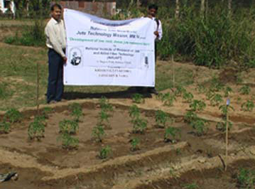
Heat Resistant tomato has been cultivated with jute mulching

After 40 days
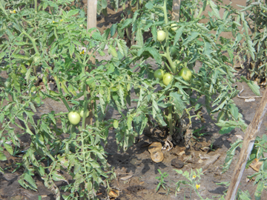

Tomato in the plant

After 65 days
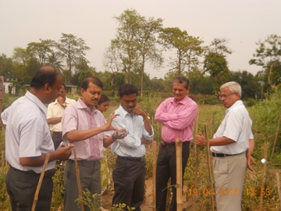
Director and other scientists of NIRJAFT are discussing with KVK scientist

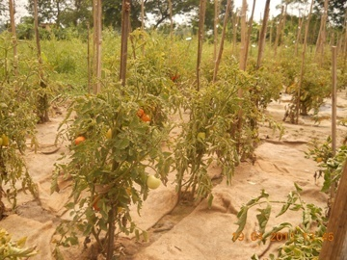
Tomato before harvesting

Experiment 2
An extensive field trial has been conducted with needle punched nonwoven as mulching cloth at Central Institute of Post Harvest Engineering and Technology, Abohar, Punjab. The trial has been done on strawberry. It is a semi arid zone with average yearly rainfall 95 cm, temperature maximum 45ºC and minimum 5ºC. Soil is sandy, clayey loam, alkaline in nature.
Different mulching types have been considered to compare jute nonwoven with conventional techniques.
Mulching type: Jute nonwoven (250, 500 and 750 g/m²), Jute woven, Black and White Plastic (7 micron and 25 micron).
Design of plot: Random block with 3 replica.

It was observed that 500 g/m² jute nonwoven shows best result in terms of plant growth, fruit yield, soil moisture retention, erosion control, hardness control, easy to laying and thermal insulation to soil. Low quality plastic material is generally used in mulching. It destroys into pieces in use. Then its removal is very difficult. Labour cost and much effort are involved to remove all the plastic pieces from the soil where jute nonwoven has no such problem because it degrades after use and become soil nutrient. Water permeability and wicking behavior of jute nonwoven helps to give better condition for the plant. As jute fabric is costlier than other mulches, this is economically viable for high valued crops only. Better thermal insulation of jute helps to retain the plant and fruit upto early summer which will fetch high earning to the farmer.
Weed reduces effectively in mulching.
250 gsm nonwoven – 49% reduction
500 gsm nonwoven – 70% reduction
750 gsm nonwoven – 62% reduction
Jute woven – 44% reduction
7 micron black plastic – 57% reduction
7 micron white plastic – No reduction

. 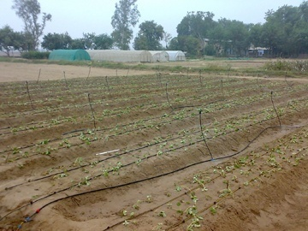
Fig 1: After plantation and showing the irrigation – without mulching

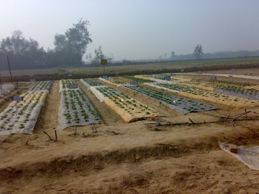
Fig 2 : After plantation with different mulching

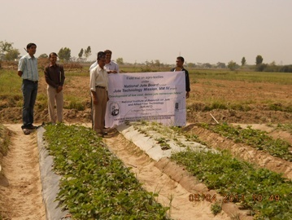
Fig 3 : Plant and fruit after 85 days

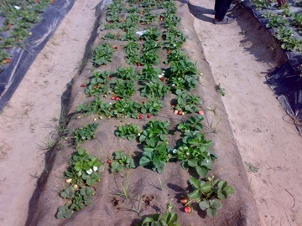
Fig 4: Fruit on jute nonwoven mulching

Field Trial on Nonwoven horticultural pot

A trial has been conducted to examine the suitability of nonwoven horticultural pot in collaboration with garden hut, Kolkata. The observations are:

- It resists soil loss during watering.
- Holds soil moisture for the longer time.
- It can directly be used on the soil.
- Jute degrades after 2-4 months and then it becomes nutrient for the plant.
- It does not damage the root of the plant

The fabric has been optimized as 350 g/m² with scrim reinforcing needle punched nonwoven fabric and found suitable for horticultural pot.

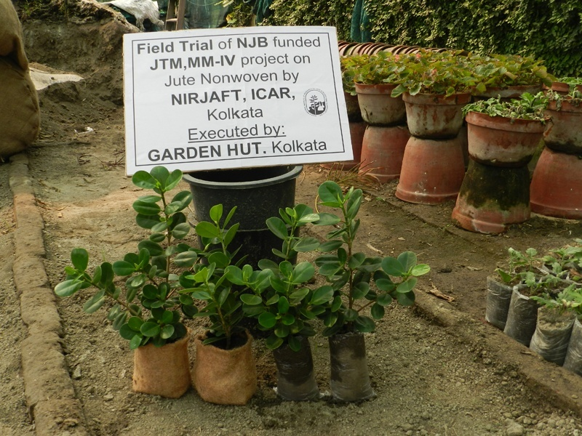
Fig 5: Jute nonwoven horticultural pot

Field Trial on Prefabricated grass mat

Different combinations were used

- Jute needle punched nonwoven (500 g/m²)
- Waste jute needle punched nonwoven (500 g/m²)
- Waste jute needle punched nonwoven with 25 micron plastic at the back
- Waste jute needle punched nonwoven with coir net at the back
- Double layer of waste jute needle punched nonwoven
- Waste jute needle punched nonwoven with jute woven fabric

Observation
Double layer 500 gsm waste jute nonwoven with approx. 4 mm soil layer gives the best result. Duration of growth before withdrawal should be maintained judiciously (approx. 2 months) so that the grass root should not reach the under soil.

- Reduces use of soil: 60%,
- Grass production increases with attractive deep green colour : 12%
- Reduces watering: 19%

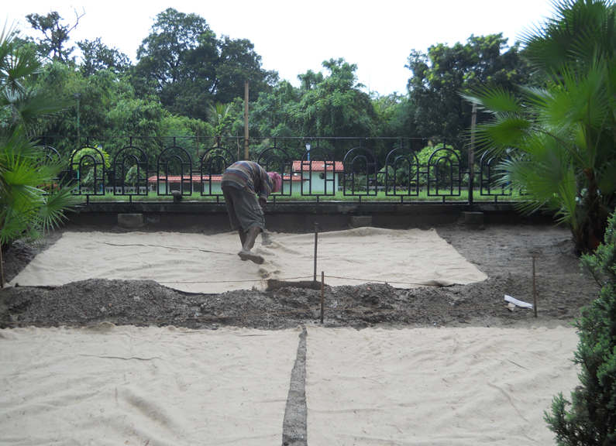

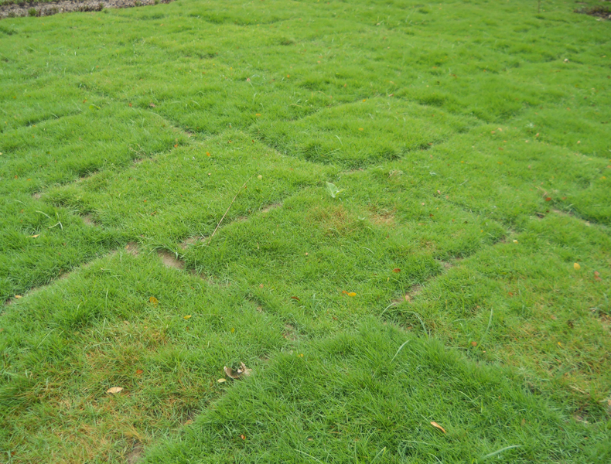

Light weight bag
An adhesive bonded fabric of 110 g/m² has been developed to make light weight carry bag which can be used as dry solid waste disposable bag. The bags are under performance testing.

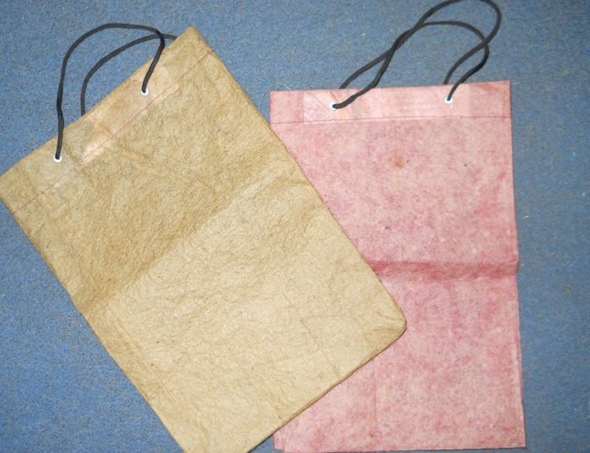
Fig 6: Light Weight Carry bag

Thermal bonded and adhesive bonded fabric

A trial has been started to optimize jute based thermal bonded and adhesive bonded fabric. For thermal bonded fabric 15 samples have been made varying gsm(100.200,300),temperature(140,180,220⁰ C)and pp percentage (40, 50, 60%). Box and Benken design have been applied for this optimization.

For adhesive bonded fabric the same Box and Benken design is used. In this case 15 samples of adhesive bonded fabric will be made varying resin concentration (5, 10, 15%), temperature (100,120,140⁰C), and pressure(0.3, 0.5, 0.7Kg/sq.cm).

Commercialization
- S Sengupta attended and discussed in Buyer Seller meet on Agricultural Textiles on 29th March, 2012 at FICCI House, New Delhi organized by Ministry of Textiles in collaboration with FICCI. About seven agricultural firms have shown interest in different uses of jute nonwovens.
- A technology transfer/Dissemination Seminar on ‘Development of low cost dense jute nonwoven fabric’ was organized at W. M. Hall, 1st level, BCCI building, 6, Netaji Subhash Road, Kolkata 700001 on 29th Jan, 2013. About 60 eminent technologists and entrepreneurs of organized and unorganized sector have shown keen interest on manufacturing and utilization of nonwoven fabrics in various value added products.
- S Sengupta, S Debnath, P K Ganguly, Jute nonwoven fabric for eco-friendly uses, Technology Transfer Seminar on 8th & 9th Nov, 2012 at Hotel Stadel, Kolkata organised by National Jute Board, Ministry of Textiles, Govt of India at Kolkata. Technologists and entrepreneurs of organized and unorganized sector have shown interest on utilization of nonwoven fabrics in various value added products.

j) Cost analysis/ cost effectiveness study report.
Submitted in the excel sheet attached herewith

k) Conclusion with recommendations- way forward.

Now-a days, research is going on to apply jute, the natural technical fibre, in different uses either alone or blended with synthetic fibres. Nonwoven technology appears to be particularly relevant to the jute industry in view of its high productivity and low wage component of the production cost associated with it. Jute based needle punched fabrics no longer competes with woven fabric in every application but has made certain outlets of its own, where technical characteristics and economic considerations reign supreme.
Needling through web material reorients some fibres vertically in the form of pegs and presence of some fibres in both the planes produce a coherent structure. Design of needle, depth of penetration, punch density, mass/unit area, fibre orientation in the web are responsible for the nature of structure produced in terms of number of loops and loop length. For jute like inextensible and rigid fibres, severe action due to needling breaks considerable number of fibres, those are oriented in vertical direction and it has an effect on structure as well as property. The irreversible disturbances in other direction due to needle penetration is also considerable in case of jute. Such a structure shows anisotropic behaviour of fabric. The breaking load of the fabric, made with a different number of passages of the web is greater than that of the fabric made with its one passage only. In general, the fabric made with a low protrusion, finer gauge, 9-barbed needle or a needle of closer barb spacing show higher values of both stress and strain. The value of tenacity of the fabric made by needling on one surface only is higher than that of the fabric made by needling on both top and bottom surfaces. With the increase in punch density and depth of needle penetration, the mechanical properties improve initially and after attaining the optimum value they deteriorate. Jute fibre cut length of 80 mm shows the optimum mechanical properties of fabric. Both stress decay and permanent set on cyclic extension of fabric are initially reduced and then show an upward trend with the increase in fabric weight, punch density and depth of penetration. The jute needled fabric with reinforcement has a good dimensional stability and the value of breaking load of the fabrics is mainly influenced by the tensile properties of the reinforcement fabric. Knowing well about the effect of various factors on the needle punched jute nonwoven, one can design the proper and effective use of such fabrics. The jute based needle punched nonwoven is used in floor-covering, insulation medium, geo-textiles, agro-textiles, filter media, household goods etc.

Today production of jute nonwoven fabric is limited to a few thousand tons of needled felts used mainly for packaging, cushioning, carpet under-laying. Thus much of the jute nonwoven textiles remain untapped. Jute needle punched nonwoven products offer cost effective and market oriented diversification for jute. However, more extensive research, intensive production and marketing expertise have to be built into the jute sector to make jute nonwovens a commercial success for jute diversification. Other areas of nonwoven technologies are unexplored for jute fabric production and there are a lot of scope for successful product diversification in those areas. Foreign nonwoven machineries are costly and hence, extensive research is required to develop the indigenous machineries to reduce the cost of production and maintenance.

