DESIGNING OF NEW METALLIC CARD CLOTHING FOR JUTE CARDS

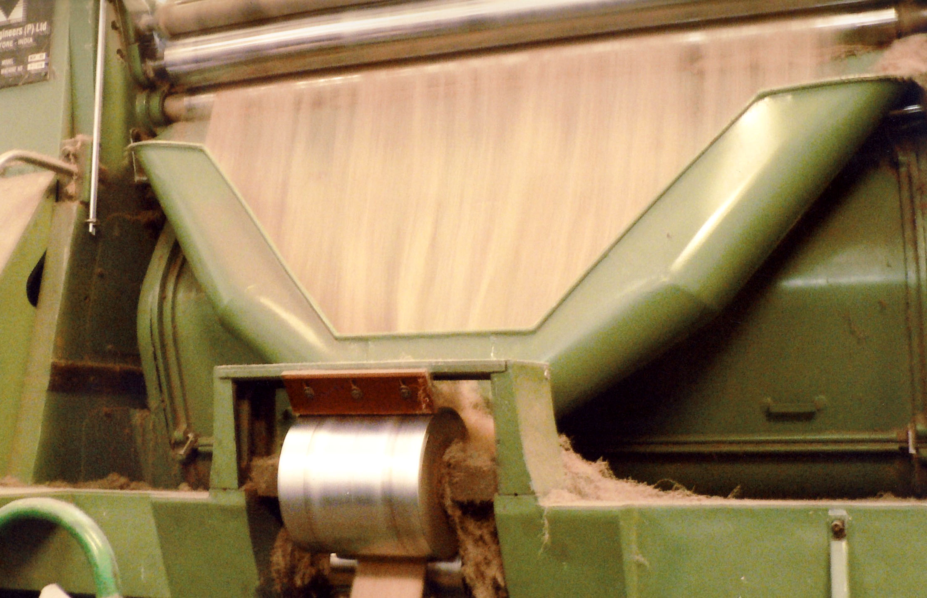

PROJECT COMPLETION REPORT (PCR)
IJSG/S/7

DESIGNING OF NEW METALLIC CARD CLOTHING FOR JUTE CARDS

PREPARED FOR:

INTERNATIONAL JUTE STUDY GROUP (IJSG)
DHAKA, BANGLADESH

PREPARED BY:

INDIAN JUTE INDUSTRIES’ RESEARCH ASSOCIATION (IJIRA), KOLKATA

IN COLLABORATION WITH

MILLTEX ENGINEERS (P) LTD., COIMBATORE, INDIA

JULY 2009

PROJECT TITLE : DESIGNING OF NEW METALLIC CARD CLOTHING FOR JUTE CARDS

PROJECT EXECUTING AGENCY : INDIAN JUTE INDUSTRIES’ RESEARCH ASSOCIATION (IJIRA), KOLKATA, INDIA
(IN COLLABORATION WITH MILLTEX ENGINEERS (P) LTD., COIMBATORE)

LOCATION : IJIRA, Kolkata & Milltex, Coimbatore, India

STARTING DATE & COMPLETION DATE

The Memorandum of Understanding between IJIRA and Milltex was signed on 09/07/2004 and between IJIRA and IJSG was signed on19/08/2004. The demonstration of the Metallic Card Clothing was conducted on 17/01/2009 bringing to the end of the long drawn project.

PROJECT COST : US$ 62,421.85

IJSG FINANCING : US$ 10,653.85

CO-FINANCING : US$ 768.00
(By IJIRA)

CO-FINANCING : US$ 51,000.00
(By Milltex)

Background

The global textile machinery has undergone changes since the days of the mechanical carding machines in 1700s. The development was spearheaded by British & European textile majors and jute mill machinery development was in the hands of British/ Irish machinery manufacturers (James Mackie and Fraser Brothers in particular).

The development process came to a standstill for the jute industry in the 1970s while the process development in cotton and other fibres such as wool, flax, silk, synthetics etc. was continued and lead by European, American and Indian industries.

There are many reasons for this situation. The main reason was the lack of interest for European textile machinery manufacturers to improve the conventional machinery and modify new technology-based machinery to adapt jute. This is due to their keen attention on the larger pie in cotton, synthetic and other emerging fibres. At the same time Indian jute product manufacturers were also reluctant and apprehensive about the adaptation of new technologies in jute sector.

The change of card clothing from wooden/ aluminium staves to metallic card clothing caused a revolution in the cotton industry and such a change would prove to be a development for the jute industry if not a revolution. The fibre characteristics does not permit major changes in the process/ machinery, however wherever possible, process/ machinery in allied industry is modified to suit jute.

One such adaptation would be the use of metallic card clothing in carding machines in place of wooden/ aluminium staves (formerly called lags).

The idea is to introduce metallic card clothing in the finisher carding machine as the fibre is pre-opened and the introduction of a new technology is easier. After careful trials in the finisher card, suitable clothing can be designed for the breaker card also.

Advantages of using Metallic Card Clothing (MCC) in cards

- Sharpness of wire points can be retained for a longer time
- Tooth Geometry can be changed easily
- Wide range of density of wire points can be achieved from 4 to 1200 points per square inch (PPSI)
- New qualities of steel combined with adequate heat treatment can be imparted for larger throughputs
- Accurate cutting of teeth and a combination of carding angle, tooth depth and population can be achieved for optimum results.
The Manufacturing Set-up (Circular Punching Type)

In the first phase, profiled wires were imported from Belgium and thereafter those were finished at Milltex. The manufacturing line has been designed based on Honnegger and Hollingsworth plants and set-up to manufacture the finished wire.

In the second phase, Milltex considers collaborating with metallic card clothing manufacturer to procure the wires for subsequent trials and commercial supply.

Advantages of MCC in Jute Cards

As mentioned earlier there is a wide range of options available for varying the population, depth of cut and carding angle, wire points across / over the periphery; scope varies from medium carbon steel wire to Tungsten Vanadium alloy steel wires. It should be noted that steel material in manufacturing MCC is virgin steel without the addition of any scrap. Virgin Steel gives uniform high hardness with tremendous strength in the blade root and abrasion resistance. But all these aspects of the card pins are not verified in the metallurgical laboratory.

With conical shape of the card pins it is absolutely impossible to have a uniform high hardness. The mass variation along tip-to-root is such that to obtain a hardness value in terms of Vickers Hardness Number (VHN) of 600, the heating operation causes the tip to melt while the region below the tip by 0.5 mm would not.
If the hardness values of the pins are plotted against the distance from the tip, a ‘drooping effect’ would be observed (Appendix-I).

Where as the hardness curve of MCC reveals that the same high hardness value is maintained up to a depth of 0.65 mm. (Appendix-I)

It is interesting to note that the hardness value of carding pins varies from 518 VHN to 550 VHN. This range of hardness would normally be prone to abrasion. Whereas 950 VHN of MCC to a depth of 0.65 mm should be definitely have more abrasion resistance yielding much longer life of the wire points.

Grinding of MCC

When the wire points become blunt in the MCC, the points can be regenerated by a light touch of grinding. The grinding process will take only four hours or less for grinding all the rollers. Hence the down time for making the card workable is much less compared to repining of the rollers.

The first grinding of the metallic wire on the rollers is the final and most important step to lead the card up to the best possible condition to offer maximum production rate. Grinding the lands of the teeth provides the leading edge of each tooth with the final sharpness required for maximum carding power.

The first grinding should be allowed to continue until at least 80% (for cylinder) and 100% (for other rollers) of the lands of the teeth have been ground sufficient to sharpen the leading edge of the tooth.

To ascertain the correct stage of grinding, it is necessary to stop the cylinder at regular interval and use a simple microscope to examine the teeth at random across and round the cylinder. If the wire on the cylinder is of good quality and has been correctly mounted, the initial grinding period should be completed within 2 to 3 hours.

It is essential to avoid over-working the wire before taking corrective action. The regrinding cycle must be determined accurately for the conditions applying in the individual mill, by using the microscope.

If regrinding is done properly, there are several advantages

- carding quality will remain consistent
- there is no risk of overworking the wire
- time required for regrinding is very short
- the exact condition of the clothing is known
- the working life of the wire is likely to be longer because the points are never allowed to become worn beyond recovery

To obtain acceptable grinding conditions at the low grinding speed, the grindstone must always be SHARP, CLEAN and CONCENTRIC. If the grinding stone is gradually allowed to become dull and glazed through constant use, the limited cutting action available will eventually disappear, resulting in burning and hooking of the carding teeth.

Due to the low peripheral speed of the grindstone which has to be used, it is most important that the speed of the wire to be ground is as high as is practicable to provide a high relative speed between the grindstone surface and the carding teeth. If wire speed is low, the individual carding tooth spends too long a time in passing under the grindstone, thereby increasing the risk of hooking and burning the tooth, which is usually irreparable.

Design of Suitable Metallic Card Clothing

Profiled wire 6.7˝ x 1.6˝ with 0.50% - 0.55% carbon and 0.40% - 0.7 % magnesium was used to provide the required strength to process a hard fibre like Jute. The wire was sourced from Belgium to ensure quality and economy of manufacture.

The profiles were designed with the existing specifications in consideration and further improvisation was done bringing in the card clothing experience. Specification design, manufactured and run are given in (Table-1 in Appendix-II and figures in Appendices III to V).

Project Objectives

Primary
- To introduce metallic card clothing in lieu of staves ensuring that the fibres are fed into carding machine and taken from it processed.
Secondary
- To control the fibre effectively from feed to delivery and thereby achieve better quality sliver
- Take out fed fibre in well-carded condition quicker to increase production
- To obtain reduced coefficient of variation (CV) percentage than staves
- To reduce loss of good fibre by offering proper degree of carding
- To understand the possibility of introducing carding elements for better carding

Targeted Beneficiaries

The jute mills would be the direct beneficiaries with possibility of higher production at lower costs and jute product users would be indirect beneficiaries with better yarn. The maintenance team in jute mills involved in re-staving can be eliminated as the grinding process is a mechanized process vis-à-vis labour intensive process. Further the time required for re-grinding is quicker and grinding equipments can be designed to complete grinding on the machine.

INSTALLATION / Mounting & PRELIMINARY TRIALS OF METALLIC CARD CLOTHING

Wire design, Manufacture & trial run were conducted at Milltex, Coimbatore. The specification for the prototype was prepared keeping in mind the existing stave specifications of jute carding machines and suitable raw materials imported from Belgium and manufactured at Milltex’s plant. One finisher card complete with roll former was installed in Milltex’s floor and preliminary trials conducted with breaker card sliver rolls bought from Sri Krishna Jute Mills, Eluru.

Mill condition Trials

The existing installation and grinding attachments are designed for 40˝ operating width and suitable modifications have been made for 72˝ - 75˝ operating width.

The wires were mounted in Milltex plant and preliminary trials conducted with fibre sourced from Sri Krishna Jute, Eluru and after demonstration at IJIRA the process started to identify a partner to conduct trials in mill conditions. Mr. Sanjay Hada of Reliance Jute Mills (International) Ltd., Kolkata was convinced of the idea and the carding machine was dispatched and installed in that Mill and since then trials have been conducted in the mill.

Initially the machine was run under the strict observation of Milltex technicians; it was subsequently run full scale. The demonstration to IJSG and industry delegation was conducted on 17/01/2009.

Learning / Experiences in Trials at Reliance Jute Mills

The machine was dispatched with rollers mounted with wires and mounting attachment. In addition to this a butt-welding machine and spare wires that may be required in case of major or minor damage to the wires, were also dispatched. The machine was installed in Reliance Jute Mills under the care of Mr. Saboo and team.

The machine was run under the careful observation of the technicians. However, with greater initiative from Mr. Hada and Milltex team, the machines were run for longer hours and trials continued. The behaviour of the wires under standard mill conditions was monitored and documented.

The trials helped to understand the problems to be faced in case of damage to wires. Damages to wires were possible due to the following:

1) Entry of hard barky portions of jute reed and adhered sticks
2) Jute sliver roll ends
3) Incorrect moisture level
4) Foreign bodies like pins etc.

Though the exact reasons for damage to the wires were not ascertained, repair work was done to correct the damage. The damaged sections of wires were removed and fresh wire added and welded to create a single coil of wires and remounted, re-gauged and machine re-installed and trials continued.

The results collected in mill conditions are given in Appendix VI.

Lessons Learnt

Metallic Card Clothing (wires) can be used to process jute fibre. The tests that were conducted are not conclusive due to the following:

a) Design / specification change required for better results
b) Additional equipment required for installation and maintenance
c) Skill levels required for installation and maintenance
d) Actual down-time due to breakdown
e) Life of the wire cannot be determined exactly
f) Cost – benefit factor cannot be finalized.

Design / Specification change required for better results

The current wire population stands at over 35 % more than that of aluminum staves. This can be reduced to 15 % and the depth of cut be maintained at 4mm. But the cut should be altered to 1 - 0.35 mm instead of 0.7 - 0.35 mm to increase strength of the wires.

Additional equipment required for installation and maintenance

Mounting tables will have to be replaced with mounting machines. These would be adapted to the card’s skeleton with an objective to attach clothing over all the rollers of the machine after mounting them on the machine.
Grinding attachment to be designed in a similar fashion would have to be attachable on the card to complete grinding without dismantling of the machines. However, the roller covers of the machines are to required be removed to give access to the rollers. The process of grinding is fast but would develop sparks due to abrasive action of the process. This area needs to be addressed with adequate covering arrangements to ensure that sparks do not cause fire.

Butt-welding machine is to be designed to ensure that high temperature is generated to aid quicker welding of wires. This machine becomes important in case of damage to wires. The process of re-joining wires is as mentioned below:

The area of damage is marked; the longer section of wires will have to be kept fixed on the rollers by temporary welding/ soldering the damaged end. Wires are uncoiled from the shorter end. It was arranged to keep aside more than the wire that is uncoiled, remove the temporary welding from the roller and weld the fresh wire to the existing wire and complete the mounting and solder the ends.

A minor grinding is resorted to ensure evenness on the wire-points to facilitate perfect gauging. Cleanliness of doffer wire is essential for better carding. Hence, cleaning rollers has to be designed and retrofitted close to the doffer, where cleaning becomes cumbersome due to the introduction of wires.

The cost of the three equipments may be approximately Rs. 4, 00,000 and can be kept in mill-storage or can be rented from the manufacturer as in the initial days of the cotton textile industry.

Skill levels required for installation and maintenance

The skill levels required for working on wires is not very high. It just needs some care so that the technician does not damage himself/ herself. A few days of training on the machines would be enough to groom a team on installation and maintenance.

Actual Down – Time due to Breakdown

In case of Reliance Jute Mills, the actual down time was very high as a team was deputed from Coimbatore to handle the breakdown and the equipment used were adapted from cotton industry and the task was laborious. However, for the new generation system, simple equipment can be designed to reduce this downtime at per with stave-damage down time.

Life of the wire cannot be determined exactly

The life of the wire could not be determined. This is due to the lack of time and facilities to run the machine to its full capability. Further tests would help us to determine the life based on the wear and tear.

Cost – benefit factor cannot be finalized

The cost of manufacturing of a commercial set of wires, which includes wire and space wire, will work out to be approximately US$ 8,000. It can be theoretically believed that the wire can be used for 6 - 8 rounds of grinding and the cost of grinding for complete set of wires would be approximately US$ 100 per machine.

Cost of staves (from experience) :

Aluminium Staves : US$ 6,500 – 8,000
Wooden Staves : US$ 4,400 – 5,000
Cost of re-staving (approximately) : US$ 900 per session every stage
Tentative life of stave: 12 years.

But theoretically in this case the situation would be as tabulated below:

Particulars | Wire  US$ |  | Alu. / Wooden Staves  US$
Initial Investment  I to VI Year (grinding /restaving)  Subsequent Investment  (spacer wire can be reused)  VII to XII Year (grinding/restaving)  Total Cost at end of 12 Years | 8,000  600  (@ US$. 100)  5,000  600  (@US$. 100)  14,200 | 7,000 / 4,500  5,400  (@US$ 900)  Nil  5,400  (US$ 900)  17,800 / 15,300

NB: 1 USD=INR 50

This is based on the following assumptions:
1) Inflation is not considered
2) Ideal situations considered without any scope for wire / stave damage. The cost of repairing of wire / stave would remain the same with new equipment.
3) Re-pinning planned with only 40% - 45% change of pins while grinding is complete.

Important findings

- Average quality ratio of sliver is higher for MCC system.
- End breakage rate, Weight C.V. %, Grist C.V. % and breaking strength C.V. % have been reduced marginally adopting MCC system.

These above data indicate improvement in performance employing MCC system vis-à-vis conventional stave system.

COST OF DEVELOPING THE METALLIC CARD CLOTHING

The total cost of developing the Metallic Card Clothing was borne by Milltex Engineers Ltd. Coimbatore, India and amounts to US$ 51,000 (US$ 1= INR 50). Details of this are given in Appendix XIV.

Comparative Test Results of Experimental Yarn, Finisher Card and Finisher Drawing Slivers vis-à-vis Control Samples (Samples prepared in conventional jute system)

Experimental and control samples of yarn, finisher card sliver and finisher drawing slivers prepared at Reliance Jute Mill were tested to evaluate their physical and mechanical properties in Physical Testing Laboratory, IJIRA. The samples were subjected to the following tests:

- Yarn: Tensile properties- USTER Tensorapid-3 (Switzerland), Twist- Good Brand Twist Tester, Yarn Abrasion Tester (US make) etc.
- Fibre-tufts from slivers: PAYER Fibre Length Analyzer, Switzerland

The test results are provided in Appendices VII to XIII.
Representative sample selection and preparation should be entirely based on stringent rules of statistics. As the test materials provided did not include all the sources of variation during processing, like, slivers collected from different shifts, prepared by different operators, collected at some scheduled different days etc., the selected samples would not be the proper representative of the actual population. The following apparent but interesting findings based on the test results of the materials supplied, were observed. Though these should not be regarded as an absolute, but a clear indication of better performance of MCC in comparison to the conventional system is visible.

Important findings

- A 10.53 % increase in Average Quality Ratio value is the most important finding.
- Tensile strength, weight C.V. % and abrasion resistance of the experimental yarn have been improved marginally.
- The experimental yarn is slightly of heavier count.
- Marginal improvement in weight C.V. % of finisher drawing sliver and finisher card sliver of experimental sample has been achieved.
- Generation of short fibre appears to be higher in experimental slivers.
- Generation of long fibre appears to be improved in experimental slivers.

Conclusions

Based on the report supplied by Milltex and the findings reported by Physical Testing Laboratory, IJIRA, the following conclusions can be drawn:

- Though the wires were found to have marginal advantage in terms of performance over staves, the sliver and yarn test results indicate improvement in product quality with adoption of MCC system.

- The cost of the wires and maintenance cost can be further reduced with the changes proposed on the design/ specification.

- Further, the reduction in pin population and strengthening of the wire base, the stability of the wires will be further enhanced and will provide scope for longer life and better quality of sliver.

- With different set of specifications of MCC the same work can be explored to judge the level of reliance about the superior performance of MCC.

- Mounting and grinding attachments suitable for operating on the card itself should be designed and developed.

- Incorporation of carding elements - further developments such as design of carding plates attached with wires. These can be fitted in cards to not only protect and prolong the life of the wire points but also aid removal of short fly micro-dust and trash and improve parallelization of fibres and consequently yield better web/sliver.

- For better transfer efficiency of doffer, cleaning rollers can be designed to be employed at the vicinity of the doffer.

- In the cotton industry, the introduction of wires caused an increase in speed of the cards and going by this, with slight modification to existing jute cards, the delivery speed can be augmented to increase production.

- The scope of MCC system for jute breaker card can also be explored.

APPENDIX-I

Drooping Effect

Steady effect

Appendix-ii
Table-1
Proposed Metallic Card Clothing (Mcc) Specifications
for Milltex Jute Finisher Cards – MJF Series

Size of Wire : 6.7˝ X 1.6˝

Space Wire SIZE : 3 X 2

Roller Name | Bare Dia. X Length  (Inch x inch) | Teeth/ inch | Teeth/ Inch² | Front Angle  a | Back Angle  B | Teeth Radius  (inch) | On Circumference | Across Card | Population | Diameter with Wires  (inch)
Cylinder | 48 X 70 | 4 | 22 | 15º | 40º | 2.1 | 603 | 386 | 232758 | 48.53
Feeder | 6.4 X 71 | 3 | 16.5 | 30º | 60º | 1.55 | 60 | 392 | 23520 | 6.93
Feed Stripper | 6.4 X 71 | 3 | 16.5 | 30º | 60º | 1.55 | 60 | 392 | 23520 | 6.93
I Worker | 10.6 X 71 | 3 | 16.5 | 30º | 60º | 1.55 | 100 | 392 | 39200 | 11.13
II Worker | 10.6 X 71 | 4 | 22 | 30º | 55º | 1.25 | 133 | 392 | 52136 | 11.13
III Worker | 10.6 X 71 | 4 | 22 | 30º | 55º | 1.25 | 133 | 392 | 52136 | 11.13
I Stripper | 10.6 X 71 | 3 | 16.5 | 30º | 60º | 1.55 | 100 | 392 | 39200 | 11.13
II Stripper | 10.6 X 71 | 3 | 16.5 | 30º | 60º | 1.55 | 100 | 392 | 39200 | 11.13
III Stripper | 10.6 X 71 | 3 | 16.5 | 30º | 60º | 1.55 | 100 | 392 | 39200 | 11.13
Doffer | 21.34 X 71 | 4 | 22 | 30º | 55º | 1.25 | 268 | 392 | 105056 | 21.87

Appendix-iii
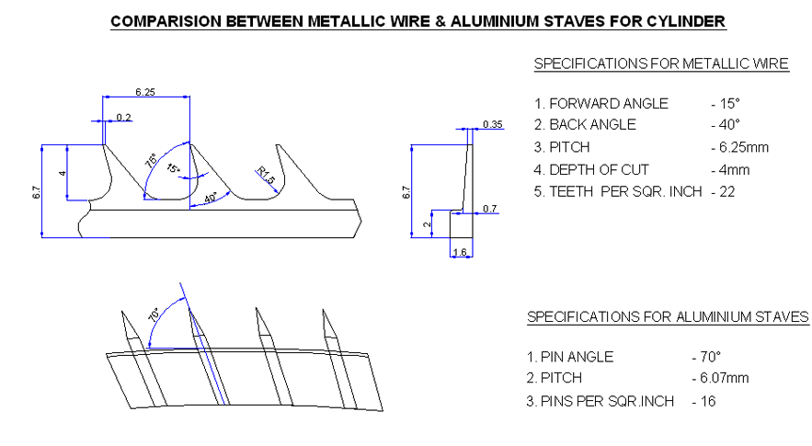

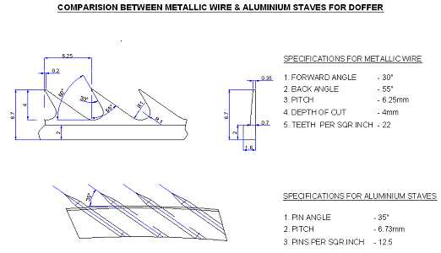

Appendix-iv

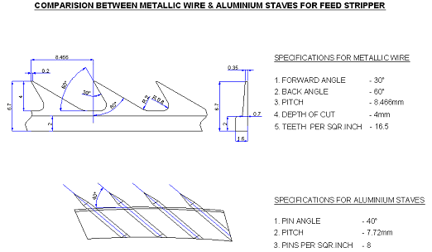

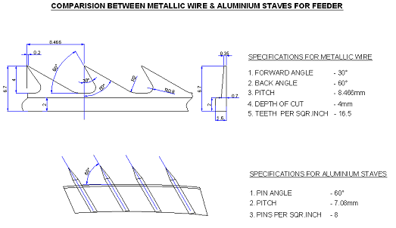

Appendix-v

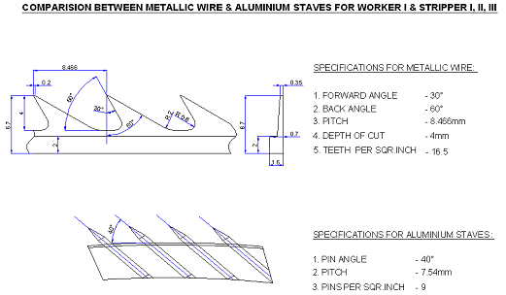

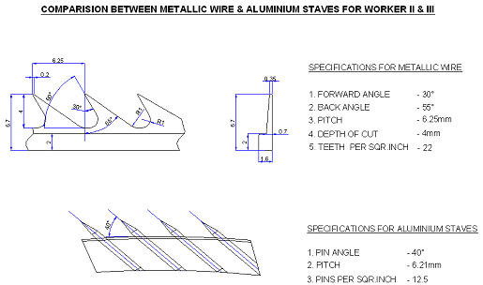

Appendix-vi

Data collected from Reliance Jute
(Based on 6 days testing, random sampling method adopted)

Particulars | Wire mounted card | Stave mounted card
1) Average wt. / 100 yards  2) CV %  3) Actual Grist  4) Grist CV%  5) Avg. Breaking Strength  6) Avg. Quality Ratio  7) Breaking Strength CV%  8) Minimum Quality Ratio  9) End Breaks / min. | 16.4 lbs  4.14  12.69  6.58  4.78 kgs/10.52 lbs  82.9  19.26  34.7  1.15 | 16.1 lbs  4.97  12.76  6.71  4.72kgs / 10.38 lbs  81.4  20.11  34.5  1.5

APPENDIX-VII

Results on Yarn

Properties | Control | Experimental
1. Grist (lbs/spyndle) at 16 % moisture regain (M.R.) | 8.8 | 9.1
2. Weight C.V.% | 2.39 | 2.02
3. Tensile Strength in kgf (lbs) | 2.91 (6.41) | 3.29 (7.25)
4. Average Quality Ratio % | 76 | 84
6. Strength C.V.% | 18.12 | 21.72
7. Twist per inch (C.V. %) | 4.40 (8.97) | 4.20 (9.52)
8. Abrasion Resistance (No. of strokes required to break the yarn) | 144 | 147
9. Elongation at Break (%) | 1.62 | 1.65

Results on Finisher Drawing Sliver

Properties | Control | Experimental
1. Moisture Observed (Converted Regain) in % | 8.0 (16) | 8.0 (16)
2. Sliver Weight (Grist) at 16% M.R. | 137.2 | 132.8
3. Weight C.V.% | 5.87 | 4.38

Results on Finisher Card Sliver

Properties | Control | Experimental
1. Moisture Observed (Converted Regain) in % | 9.0 | 9.2
2. Sliver Weight (Per 100 Yards) at 16% M.R. | 13.57 | 13.08
3. Weight C.V.% | 3.79 | 2.94
APPENDIX-VIII

Results on Fiber Tufts of Finisher Drawing Slivers for determining Fiber Length Distribution on the basis of Fiber Number

Properties | Control | Experimental
 | Set-I Set-II | Set-I Set-II
1. Mean Fibre Length (mm) | 65.1 57.9 | 60.4 58.6
2. Short Fibre Content %  (% of fibres shorter than the specified value)  %< 5 mm  %< 12.5 mm  %< 25 mm  %< 50 mm | 0 0.6  7.5 11.6  25.2 33.4  50.5 55.8 | 0.5 0.7  5.0 17.1  25.7 32.4  56.2 57.6
3. Long Fibre Length (mm)  (minimum fibre length attained by the specified % of fibres)  L 95 %  L 75 %  L 50%  L 5.0 %  L 2.5 %  L 1.0 % | 10.5 7.0  24.9 19.6  49.3 39.7  169.4 162.5  200.3 186.0  222.5 207.8 | 12.5 7.0  24.7 21.9  43.9 43.2  163.6 157.9  187.4 193.6  227.6 217.4

Results on Fiber Tufts of Finisher Drawing Slivers for determining Fiber Length Distribution on the basis of Fiber Weight

Properties | Control | Experimental
 | Set-I Set-II | Set-I Set-II
1. Mean Fibre Length (mm) | 106.3 98.4 | 99.6 100.7
2. Short Fibre Content %  (% of fibres shorter than the specified value)  %< 10 mm  %< 12.5 mm  %< 25 mm  %< 50 mm | 0.6 1.2  1.1 1.6  6.0 8.6  20.2 23.2 | 0.4 1.8  0.6 2.5  7.2 8.1  25.9 24.4
3. Long Fibre Length (mm)  (minimum fibre length attained by the specified % of fibres)  L 95 %  L 75 %  L 50%  L 5.0 %  L 2.5 %  L 1.0 % | 22.3 19.1  55.9 51.8  97.3 90.5  211.8 203.8  224.2 215.9  240.3 217.8 | 22.0 21.7  49.0 56.9  87.7 90.4  223.7 208.6  234.2 225.0  257.4 254.6

APPENDIX-IX

Results on Fiber Tufts of Finisher Card Slivers for determining Fiber Length Distribution on the basis of Fiber Number

Description of Test | Control | Experimental
 | Set-I Set-II | Set-I Set-II
1. Mean Fibre Length (mm) | 41.7 44.8 | 35.5 39.8
2. Short Fibre Content %  (% of fibres shorter than the specified value)  %< 5 mm  %< 12.5 mm  %< 25 mm  %< 50 mm | 2.7 0.1  26.3 22.5  47.2 48.6  71.2 72.1 | 4.6 0.2  34.6 25.5  59.0 53.4  76.9 75.2
3. Long Fibre Length (mm)  (minimum fibre length attained by the specified % of fibres)  L 95 %  L 75 %  L 50%  L 5.0 %  L 2.5 %  L 1.0 % | 5.7 7.4  11.9 13.3  26.8 26.0  129.8 146.2  157.4 193.6  178.5 219.2 | 5.1 7.0  9.6 12.4  18.8 23.0  123.4 134.0  153.0 156.5  190.9 196.7

Results on Fiber Tufts of Finisher Card Slivers for determining Fiber Length Distribution on the basis of Fiber Weight

Description of Test | Control | Experimental
 | Set-I Set-II | Set-I Set-II
1. Mean Fibre Length (mm) | 84.4 95.6 | 79.2 83.5
2. Short Fibre Content %  (% of fibres shorter than the specified value)  %< 10 mm  %< 12.5 mm  %< 25 mm  %< 50 mm | 3.5 2.5  5.1 4.7  14.3 15.2  34.9 33.9 | 5.2 3.3  7.8 5.8  20.1 18.3  38.1 37.7
3. Long Fibre Length (mm)  (minimum fibre length attained by the specified % of fibres)  L 95 %  L 75 %  L 50%  L 5.0 %  L 2.5 %  L 1.0 % | 12.3 12.9  37.1 37.0  73.4 81.2  177.5 241.1  184.5 270.4  218.3 274.2 | 9.8 11.7  30.9 32.5  69.1 70.9  192.1 197.7  206.8 212.4  221.3 228.8

APPENDIX-X

Distribution of Fibre Length by % Number
Finisher Card Control Sliver

Set I | Set II

Distribution of Fibre Length by % Weight
Finisher Card Control Sliver

Set I | Set II

APPENDIX-XI

Distribution of Fibre Length by % Number
Finisher Card Experimental Sliver

Set I | Set II

Distribution of Fibre Length by % Weight
Finisher Card Experimental Sliver

Set I | Set II

APPENDIX-XII

Distribution of Fibre Length by % Number
Finisher Drawing Control Sliver

Set I | Set II

Distribution of Fibre Length by % Weight
Finisher Drawing Control Sliver

Set I | Set II

APPENDIX-XIII

Distribution of Fibre Length by % Number
Finisher Drawing Experimental Sliver

Set I | Set II

Distribution of Fibre Length by % Weight
Finisher Drawing Experimental Sliver

Set I | Set II

APPENDIX-XIV

COST OF THE MANUFACTURE OF METALLIC CARD CLOTHING:

The manufacturing line required for the manufacture of metallic card clothing has been designed, devised and installed. The required testing and mounting facilities have been designed and commissioned by Milltex Engineering Ltd. at Coimbatore, India.

The investment in the project is as mentioned below:

(a) Cost of Imported Profiled Wire (300 Kgs.) - @ Rs. 2,45,000

(b) Cost of Imported Spacer Wire (150 Kgs.) - @ Rs. 40,000

(c) Cost of Manufacturing Line - @ Rs. 3,30,000
(Circular Punching Line)

(d) Operating Cost of Man Manufacture Prototype
Wires for One Full Card - @ Rs. 85,000

(e) Cost of Re-designed Equipment - @ Rs. 3,50,000
(Mounting & Grinding)

(f) Approximate Cost of Finisher Card - @ Rs. 15,00,000

TOTAL COST OF THE PROJECT @ Rs. 25,50,000

OR

@ US$ 51,000

NB: 50 INR = 1 US$

