Monitoring data reporting format of the field application using JGT for rural road sites under the project CFC/IJSG/21

Name of the site / Name of the Executing Agency : | Length constructed with JGT :
Date of the commencement of construction : | Type of soil :
Date of the end of construction : | CBR of Sub-grade Soil :
Date of opening of road for traffic : | Estimated ESAL mentioned :

Date of Assessment  (Period of assessment) | Type of assessment (Machine aided)
Date of Assessment  (Period of assessment) | CBR of Sub-grade  (%) |  |  |  |  | Optimum Moisture Content (%) &  Maximum Dry Density (kg/m³) |  |  |  |  |  | Sub-grade Void Ratio
Date of Assessment  (Period of assessment) | With JGT |  | Control Section |  |  | With JGT |  |  | Control Section |  |  | With JGT |  | Control Section
 | Assessment of Distress Condition (Instrument Aided)
Date of Assessment  (Period of assessment) | Thickness of Pavement components  (mm) |  |  | Nature of Cracks on surface¹  (%) |  |  | Rutting²  (mm) |  |  | Potholes³  (%) |  |  | Traffic Assessment |  | Remarks
Date of Assessment  (Period of assessment) | With JGT | Control Section |  | With JGT | Control Section |  | With JGT | Control Section |  | With JGT | Control Section

NB: Separate page to be used for each assessment. At the end of six assessments, a summary page to be prepared for submission.

- Mention type of cracks e.g. Alligator (A), Longitudinal (L), Transverse (T) and measure it by accumulating the length along the surveyed lane of each type of cracking. Divide the accumulated lengths of cracks by the total length to be surveyed. Multiply by 100 to get percent, and round to a whole number.
- Rut depth can be measured with a 1.2 m straight edge stick at suitable intervals and can be categorized as low condition (when rutting < 10mm), medium (when rutting is between 10 – 20mm) and high (when rutting >20mm).
- Potholes can be categorized according to their severity levels as low (when < 25mm deep), moderate (when 25 – 50 mm deep) and high (when > 50 mm deep). Potholes may be measured by cumulating its number and affected area divided by total area to be surveyed and then multiplying by 100 to get percent.

Inspection Procedure and Guidelines
The elements of pavement condition rating are as follows:
1. The type of defect.
2. The severity of the defect.
3. The extent to which the road surface is affected by the defect.
There are several types of defects and several possible severities and extents for each defect.
These are described and illustrated below:

1A. Alligator Cracking
Alligator fatigue cracking is associated with loads and is usually limited to areas of repeated traffic loading. The stage at which several discontinuous longitudinal cracks begin to interconnect, is defined as alligator cracking. Eventually the cracks interconnect sufficiently to form many pieces, resembling the pattern of an alligator.
Severity:
Low —Discontinuous thin cracks are beginning to interconnect and form the typical alligator pattern with no spalling.
Medium - Cracking has fully developed an alligator pattern. The cracks may be greater than 6 mm wide, but the pavement pieces are still in place.
High — The pattern of cracking is well developed. Spalling is very apparent at the crack. Individual pieces may be loosened and may rock under traffic.
Low Medium High
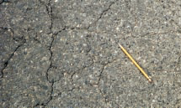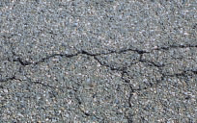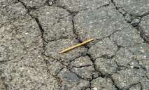

1B. Longitudinal Cracking
Longitudinal cracks run roughly parallel to the roadway center line.
Severity:
Low — The cracks have very little or no spalling along the edges and are less than 6 mm in width.
Medium — The cracks have little or no spalling but they are greater than 6 mm in width.
High — Pieces of riding surface are visibly missing along the crack. At some point, this longitudinal cracking becomes alligator cracking.
Low Medium High
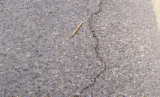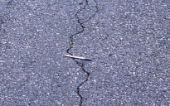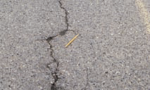

1C. Transverse cracking
Cracks that is predominantly perpendicular to pavement centerline. Cracks less than 0.3 m in length are not recorded.
Severity :
Low - An unsealed crack with a mean width < 6 mm; or a sealed crack with sealant material in good condition and with a width that cannot be determined.
Medium - Any crack with a mean width > 6 mm and < 19 mm; or any crack with a mean width < 19 mm and adjacent low severity random cracking.
High - Any crack with a mean width > 19 mm; or any crack with a mean width < 19 mm and adjacent moderate to high severity random cracking.
Low Medium High
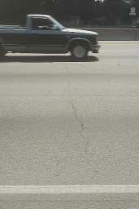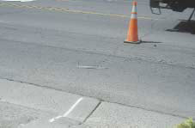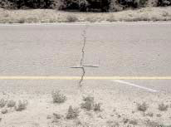

2. Rutting
Rutting is a surface depression within the wheel path. Rutting results from a permanent deformation in any of the pavement layers or subgrades, usually caused by consolidation or lateral movement of the materials due to traffic loads.
Rut depth can be measured with a 1.2 m straight edge stick at suitable intervals and can be categorized as low condition (when rutting < 10mm), medium (when rutting is between 10 – 20mm) and high (when rutting >20mm).
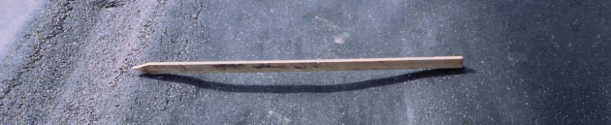

3. Potholes
Bowl-shaped holes of various sizes in the pavement surface. Minimum plan dimension is 150 mm.
Severity:
Low - < 25 mm deep
Medium - 25 mm to 50 mm deep
High - > 50 mm deep

Low Medium High
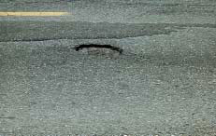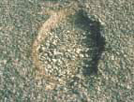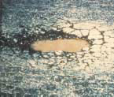

Rating Considerations
Important factors to consider when to collect pavement condition data.
- It is recommended that a finite value (the actual percentage or count) of the extent is recorded for each of the severity categories as use of ranges will probably result in too large an extent for the total of the severities.
- Roads to be rated by inspection on foot. A single lane is generally used, but if time allows, an agency can measure more than one lane.
- The relative sun angle and direction of viewing the roadway surface will greatly affect visual observation. Be sure to view the pavement from more than one direction occasionally during the survey to assure the true nature of the pavement surface is being observed.
- The time of year and weather (moisture and temperature) conditions over a given time period can also affect the severity and visibility of certain distresses. If at all possible, rate the roadway network at a similar time of the year and only whiles the pavement is dry.
- When rating, observe the entire area of the traveled roadway segment constructed using JGT or a sample 1 km section constructed with JGT. Where a control section (without JGT) is available, comparative data are to be recorded.
- When rating the width of cracks, use the average width, not the extremes.
- Condition ratings apply only to the traveled surface of a road. Do not include the conditions of shoulders or other adjacent areas. Shoulder condition, drainage information, or other items may be accounted for and collected separately from or with the pavement rating data.
- When any type of defect is not observed, write a “Nil” in the first space on the field form for that defect. The “Nil” indicates clearly that a defect was not present.
- The agency may wish to observe and collect additional information during the survey and this may be recorded in the remarks column.
- It is important that the agency collecting monitoring data must receive the above direction related to data collection prior to beginning the survey project.

